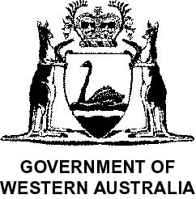

CLEARING PERMIT

Granted under section 51E of the Environmental Protection Act 1986

PERMIT DETAILS
Area Permit Number:108 / 1
File Number:18834
Duration of Permit: From 13 November 2004 to 13 November 2006

PERMIT HOLDER
Neville Robert Wren

LAND ON WHICH CLEARING IS TO BE DONE
Lot 9196 on Plan 201691, Manjimup

AUTHORISED ACTIVITY
1. Clearing of up to 6 hectares of native vegetation within the area cross hatched yellow on attached Plan 108/1.

CONDITIONS
1. Nil.

__________________________

Derek Carew-Hopkins
Program Manager

Chief Executive Officer, Department of Environment.
13 October 2004

