Mindarie to Burns Beach Dual Use Path - Tamala Conservation Park Amendment Revegetation Plan CPS 8220/3

April 2025

Lot 9505 on DP 52070

Contents
1. Introduction 2
2. Existing Environment 3
2.1 Land Tenure and Zoning 3
2.2 Vegetation and Flora 5
2.3 Soil and Landforms 9
2.4 Hydrology 9
2.5 Fauna 9
3. Site History 10
3.1 Indigenous Heritage 10
3.2 Land Use 10
4. Potential Impacts 11
4.1 Weeds 11
4.2 Rubbish 12
4.3 Unauthorised Access 12
4.4 Inappropriate Fire Regimes 13
4.5 Phytophthora Dieback 14
5. Revegetation commitments 15
6. Reference Site Floristic Data 15
7. Targets and Completion Criteria 20
7.1 Vegetation Establishment 20
7.2 Seed Collection, Plant Salvage and Propagation 20
7.3 Topsoil and Mulch 25
7.4 Site Preparation and Protection 26
8. Maintenance 27
9. Schedule and Budget 27
10. Monitoring and Analysis 29
11. References 30
12. Appendices 31
Appendix A: Site Photos 32
Appendix B: Biological Survey 38
Appendix C: Specifications 39

Introduction
Tamala Conservation Park (the Park) encompasses an area of 381 hectares of coastal vegetation that is situated between the suburbs of Burns Beach and Mindarie and is bound by the Indian Ocean to the west and Marmion Avenue to the east (Figure 1). The Park lies within Bush Forever site 322, known as Burns Beach Bushland. The City of Joondalup (CoJ) in partnership with the City of Wanneroo (CoW) and the Western Australian State Government are proposing to clear 2.53 hectares of coastal vegetation to facilitate the construction of a Dual Use Path (DUP).
CoJ submitted a Native Vegetation Clearing Permit (NVCP) application to clear 2.53 hectares of coastal vegetation to the Department of Water and Environmental Regulation (DWER) for assessment (CPS 8220/2). DWER carried out a preliminary assessment of the application and identified that the proposed clearing is at variance with Clearing Principle (h). In accordance with State Planning Policy 2.8 Bushland Policy for the Perth Metropolitan Region (SPP 2.8) (WAPC, 2010) a 2:1 offset ratio is required to counterbalance the removal of 2.53 hectares of native vegetation within Bush Forever site 322. As such, the CoJ Rehabilitated 1.7ha of areas disturbed during construction of the DUP; and provided monetary contribution for 3.336 ha to DWER offset fund.

The purpose of the Mindarie to Burns Beach Dual Use Path - Tamala Conservation Park Revegetation Plan (the Plan) is to guide the on ground works relating to revegetation of 1.7ha of areas disturbed during development of the DUP as well as the revegetation of 0.002ha and to address the impacts to Bush Forever Site 322.

This revegetation plan has been developed in accordance with ‘A Guide to Preparing Revegetation Plans for Clearing Permits under Part V of the Environmental Protection Act 1986’ (DWER, 2023). And has been accepted as part of the approval process for CPS 8220/3 that was granted on the 24 June 20220.

The City of Wanneroo (CoW) on behalf of the City of Joondalup wishes to make an amendment to clearing permit CPS 8220/3. To comply with the Bushfires Act 1954 CoW is required to install a firebreak, that will intersect the revegetation site. The fire break will require the removal of 0.002ha of vegetation from the offset area allocated against CPS 8220/3. To compensate for the loss, the CoW wishes to advise that an alternative revegetation area within Bush Forever Site 322 has been identified.

The CoW proposes: Rehabilitation of 0.011ha in an alternative offset area located within close vicinity to the original revegetation area ns still within Lot 9505, DP 52070, Mindarie 6030 Bush Forever Site 322.

REFER TO SECTION 6 (Figures 5 – clearly indicate the small amendment for CP 8220/3)

Correspondence relating to the technical aspects of this Plan and anything regarding the Clearing Permit should be addressed to:

Primary
Wendy Mason
Environmental Asset Planner 08 9405 5511
City of Wanneroo
Wendy.Mason@wanneroo.wa.gov.au
AssetsEnvironmentalMailbox@wanneroo.wa.gov.au

The CoJ and CoW undertake revegetation projects on an annual basis as part of their Capital Works programs and have internal resources providing expertise on completion criteria and onsite revegetation techniques.

Existing Environment

Land Tenure and Zoning
The proposed DUP is located within three separate land parcels, of which all are zoned for Public Recreation under the Metropolitan Region Scheme. The proposed DUP is located within the CoJ and CoW local government boundaries. A summary of land tenure and zoning is provided in Table 1, below and Figure 1.
Table 1: Land tenure and zoning
Lot Number | Land Owner / Manager | MRS Zoning | Reserve Purpose
Lot 3000 on Deposited Plan 44066 | Burns Beach Management (PEET) | Parks and Recreation | NA - Freehold
Lot 3050 on Deposited Plan 47951 | City of Wanneroo | Parks and Recreation | Public Recreation – Reserve 35890
Lot 9505 on Deposited Plan 52070 | Western Australian Planning Commission | Parks and Recreation | NA - Freehold

The Tamala Conservation Park Establishment Plan (Government of Western Australia, 2012) identifies land vesting arrangements as a current issue within the Park. A recommendation of the plan includes a proposal for the Park to be managed by the Department of Biodiversity Conservation and Attractions (DBCA). It is possible that land tenure will change in the future, however timeframes for this are unknown.

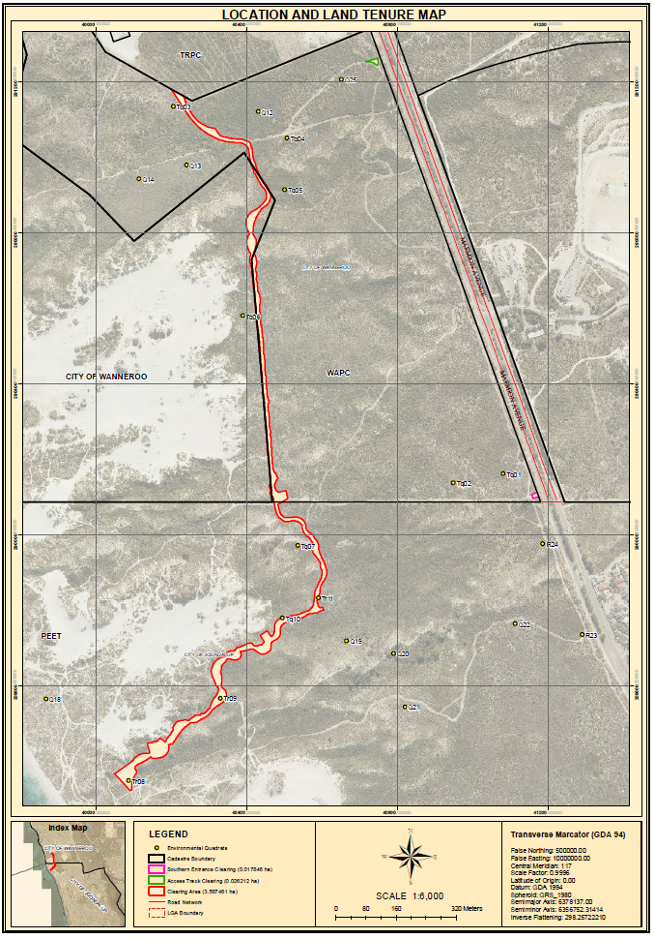 Figure 1: Location & Land Tenure Plan (Source: AECOM, 2018)

Vegetation and Flora
The construction extent of 2.81 ha lies within the DUP Alignment, which is 15.14 ha and runs north-south across the Survey Area, as defined in Figure 2. The DUP alignment is defined as a detailed survey area 25 metres either side of the construction extent where AECOM’s 2018 targeted survey effort was focussed.
Figure 2: Survey Area (Source AECOM,2018)
2

A Level 2 Flora and Vegetation Survey was undertaken by AECOM in 2018 (Appendix B). Three PEC’s were recorded in the Park which include:
- Coastal shrublands on shallow sands (29a);
- Acacia shrublands on taller dunes (29b); and
- Northern Spearwood shrublands and woodlands (24).

Northern Spearwood shrublands and woodlands (24) is the largest represented PEC, with 6.14 ha occurring within the DUP alignment, of which 1.32 ha occurs within the construction extent. Acacia shrublands on taller dunes (29a) also occurs within the DUP alignment (1.2 ha), of which 0.49 ha occurs within the construction extent. Coastal shrublands on shallow sands is not represented within the DUP alignment.
Nine vegetation communities and two degraded areas were mapped within the Survey Area (AECOM, 2018) which forms part of a coastal mosaic, typical of dune systems. The vegetation types included two woodlands; six shrublands and one thicket. The main vegetation communities represented in the survey area included:
- OaCA (83.96 ha);
- MsLm (70.61 ha); and
- SgAp (35.82 ha).

Of these, MsLm is the most commonly represented vegetation community within the DUP alignment. Appendix A includes photos of the vegetation occurring in the DUP alignment.
The condition of vegetation mapped within the DUP alignment ranged from Degraded to Very Good, with the majority mapped as Very Good based on the Keighery (1994) vegetation condition scale (Figure 3). The CoW has manually changed the vegetation of the cleared tracks from Degraded to Completely Degraded, based on the lack of vegetation within the cleared track and in accordance with the Keighery (1994) Vegetation Condition Scale.
A total of 86 flora species were recorded within the Park. No flora species of conservation significance were recorded in the survey.

- Figure 3 a: Vegetation Condition, Northern section of DUP
Figure 3b : Vegetation Condition, Southern section of DUP

Soil and Landforms
The proposed DUP lies on coastal dunes, consisting of beach sand, sand dunes, coastal dunes, calcareous and siliceous, locally shelly and/or cemented beach rock (AECOM, 2018).
Soil land systems within the DUP alignment comprise of Spearwood and Quindalup systems. The majority of the DUP alignment occurs within the Quindalup Sands system, with the northern most section located within the Spearwood System (WALGA, 2018).
The presence of Acid Sulphate Soils within the Park is considered low or no risk (AECOM, 2018).

Hydrology
A review of the wetlands of the Swan Coastal Plain feature maps identified that there are no surface water expressions within the Park. The closest wetland is Pauls Swamp, a Conservation Category Wetland located approximately 4 km east of the reserve (AECOM, 2018).
Depth to ground water ranges from between 40m below ground level in the east to 6m in the west (AECOM, 2018). The groundwater salinity levels are considered ‘marginal’ with TDS levels 500 - 1000mg/L (AECOM, 2018).

Fauna
A Level 1 Fauna Survey was undertaken by AECOM (2018) and GHD (2013). Results of the survey found that the survey area comprises of four main habitat types (AECOM, 2018), including:
- Shrubland mosaic;
- Woodland Over Mid to Low Shrubland;
- Low Shrubs on Mobile Dunes; and
- Shrubland Mosaic with isolated Eucalyptus gomphocephala.

Of the four main habitat types that occur within the survey area, only two occur within the DUP alignment and construction extent. Shrubland mosaic is the most common fauna habitat, with 10.06 ha occurring within the DUP alignment, of which 1.72ha is located within the construction extent. The remaining DUP alignment and construction extent comprises of low shrubland on mobile dunes, with 3.5 ha and 0.97 ha, respectively.
The desktop study found that 15 conservation significant fauna species that are likely or may occur within the Study Area, these are;
- Quenda (Isoodon fusciventer);
- Western Brush Wallaby (Notamacropus Irma).
- Carnaby's Black-Cockatoo (Calyptorhynchus latirostris);
- Osprey (Pandion haliaetus);
- White-bellied Sea-Eagle (Haliaeetus leucogaster);
- Peregrine Falcon (Falco peregrinus);
- Black-striped Snake (Neelaps calonotos);
- Western Brush Wallaby (Notamacropus Irma);
- Graceful Sunmoth (Synemon gratiosa); and
- Rainbow Bee-eater (Merops ornatus).

Three of these species were recorded during field observations:
- Carnaby’s Black Cockatoo (Calyptorhynchus latirostris);
- Quenda (Isoodon fusciventer); and
- Western Brush Wallaby (Notamacropus Irma).

Site History

Indigenous Heritage
The long history of indigenous and European interaction with the local topography of the Tamala Park landscape is evident, with the juxtaposition of both conservative and development visions for this area.
The northern portion of the construction extent intersects with a registered Aboriginal heritage site, Place ID 3567 Mindarie Waugal. A report on the potential impacts of the proposed DUP on the site was completed and an application under section 18 of the Aboriginal Heritage Act 1972 was submitted. The application was submitted in October 2018, with approval provided by the Minister of Aboriginal Affairs on 16 January 2019 (Reference 69-12011).

Land Use
Tamala Park has long been associated with both development and conservation land use. Over several decades, the differing visions of conservation and development for this area, has resulted in the integration and balancing of these values and results in the present day land use.
Historically in the 1890s, pastoral leases were issued in the Tamala Park area. Following pastoral use, the origins of residential use in the Burns Beach settlement began with the creation of a reserve for health and camping in 1908. In 1969, Burns Beach Property Trust acquired Lot 2, increasing the potential of the area being developed further (Government of Western Australia, 2012).
In 1977, the potential conservation value of the area was identified with the proposal of a regional open space area between the coast and Neerabup National Park as part of the North West Corridor structure plan. In 1983, the Department of Conservation and Environment identified potential conservation reserves in a portion of Lot 2 Burns Beach and Lot 17 Mindarie. The significance of the dune system feature between Burns Beach and Mindarie was further recognised in 1991 by an environmental audit for Department of Planning and Urban Development.
In contrast, the potential for the area to be further developed was also growing momentum. In 1981, the coastal reserve, north of Lot 2 Burns Beach was identified for waste disposal, with the acquisition of Lot 17 Mindarie by the Cities of Perth and Stirling and Shire of Wanneroo. Despite public opposition, the Tamala Park waste disposal facility was opened in 1991, managed by Mindarie Regional Council for the Cities of Perth, Stirling and Wanneroo.
In 1994, the Burns Beach Property Trust proposed part urban development (252ha) of 290ha of Lot 2 Burns Beach. With ongoing community opposition, the Environmental Protection Authority (EPA) requested a formal environmental assessment of the proposal. The level of the assessment was later raised after an appeal was lodged by conservation groups, marking the start of the campaign to protect the bushland north of Burns Beach.
In 1998, the State Government recommended the protection of part of Lot 2 Burns Beach and Lot 17 Mindarie bushland, as part of a regional conservation assessment. In the same year, the EPA reported on the PER development proposal, recommending that only 55ha of part of Lot 2 could be developed due to the regional conservation value of the remaining 235ha. In support of the 1998 regional conservation assessment, the State Government released the 2000 Bush Forever report, identifying bushland on part of Lot 2 and Lot 17 for conservation.

In 1999, the WAPC initiated MRS Amendment 992/33, which proposed urban zoning of 170ha of part of Lot 2 Burns Beach and the inclusion of 120ha of Lot 2 and part of the western portion of Lot 17 in parks and recreation reserve. In response, the EPA reiterated its previous recommendation to limit development to 55ha of Lot 2.
In 2002, the Environment Minister established a committee to review appeals against the EPA report on the urban development of part of Lot 2 Burns Beach. This resulted in the Environment and Planning Ministers agreeing on a resolution in 2003, with 146ha of part of Lot 2 rezoned to urban and 144ha reserved for parks and recreation. Furthermore, the WAPC and relevant local councils agreed on an area to be set aside for conservation, under the Bush Forever initiative.
In 2009, the Tamala Park Local Structure Plan No. 79 was prepared covering 179 ha of the entire site area (WAPC, 2012), including 9 ha of non-residential land use (schools, drainage, local and neighbourhood centres) and 170 ha of gross subdivisible area (TPG, 2012). The WAPC established an advisory committee to progress an establishment plan for the proposed conservation reserve between Burns Beach and Mindarie in 2009 to guide the long term management of the area.
Prior to the development of Burns Beach in 2014, aerial imagery identifies the land immediately south of the proposed DUP, consisting of uncleared native vegetation, with some minor tracks (Landgate aerial imagery, 2019). Aerial imagery also illustrates that the northern portion of the DUP consisted of uncleared remnant vegetation until mid-2015, prior to the development of Catalina Estate (Landgate aerial imagery, 2019).
The City of Wanneroo received a Management Order for Tamala Park (Reserve 35890, Lot 3050 on Deposited Plan 47951), designated for the purposes of ‘public recreation’, on 7 October 2005. Regular inspections of this reserve are carried out by CoW local government officers for periodic weed management, pruning and rubbish collection. Unauthorised vehicles, weeds and illegal dumping are commonly identified as disturbances in Reserve 35890.
In 2020, the City of Joondalup cleared up to 3.06 hectares of native vegetation within Lot 9505 on Plan 52070 and Marmion Avenue Road reserve (PIN 1135104), Tamala Park, and Lot 3050 on Plan 47951 and Lot 9026 on Plan 415564, Mindarie, and Lot 3000 on Plan 44066, Burns Beach, for the purpose of constructing a dual use pathway.
Aerial imagery of the area adjacent to the proposed DUP alignment, demonstrates that the large blowouts, existed in 1965 (Landgate aerial imagery, 2019). Informal tracks in the survey area appear to have increased in frequency from 2000 to present.

Potential Impacts
Threats that have the potential to impact on the DUP project include fire, feral animals and disease. Details of these threats are discussed below, with suggested mitigation actions, responsibilities and compliance criteria provided with the schedule, in Table 5.

Weeds
A weed survey was conducted by AECOM in 2018 to identify all weed populations within the proposed DUP alignment. AECOM (2018) observed 34 taxa, in 80 weed population areas, mainly adjacent to the existing tracks. Table 2 summarises these species and their priority for management according to Bettinck & Keighery (2008). Four weed species were rated as very high priority and seven species were rated high priority.
Table 2: Introduced species and priority for management recorded within Tamala Park (AECOM, 2018).
Species | Common name | Priority for Management
Arctotheca calendula | Capeweed | High
Asparagus asparagoides | Bridal Creeper | Very High
Avena barbata | Bearded Oat | Very High
Brassica tournefortii | Mediterranean Turnip | Unknown
Briza maxima | Blowfly Grass | Unknown
Briza minor | Shivery Grass | Unknown
Bromus diandrus | Great Brome | Very High
Cakile maritima | Sea Rocket | Low
Centaurea melitensis | Maltese Cockspur | Medium
Cuscuta planiflora |  | Unknown
Ehrharta longiflora | Annual Veldt Grass | Unknown
Erodium botrys | Long Storksbill | Unknown
Euphorbia paralias | Sea Spurge | High
Euphorbia terracina | Geraldton Carnation Weed | Very High
Fumaria capreolata | Whiteflower Fumitory | Medium
Heliophila pusilla |  | Low
Hypochaeris glabra | Flatweed, Smooth Catsear | High
Lagurus ovatus | Hare's Tail Grass | High
Lolium perenne | Perennial Ryegrass | Medium
Lysimachia arvensis | Pimpernel | Unknown
Moraea flaccida | One-leaf Cape Tulip | High
Pelargonium capitatum | Rose Pelargonium | Med/High
Pentameris airoides | False Hairgrass | Medium
Petrorhagia dubia | Velvet Pink | Medium
Romulea rosea | Guildford Grass | High
Solanum nigrum | Black Berry Nightshade | Medium
Sonchus asper | Rough Sowthistle | Medium
Trifolium dubium | Suckling Clover | Unknown
Vellereophyton dealbatum | White Cudweed | Medium
Watsonia meriana var. bulbillifera | Watsonia | High
The most common weeds recorded were, Euphorbia terricina (51 population areas), Bromus diandrus (47 population areas) and Pelargonium capitatum (46 population areas). One Weed of National Significance (Bridal Creeper - Asparagus asparagoides) was recorded within the survey area and at several locations along the DUP alignment. Bridal Creeper is also listed as a Declared Pest under the Biosecurity and Agriculture Management Act 2007.

Rubbish
Dumping of waste is a common occurrence throughout bushland reserves and parks in residential areas. The dumping of lawn clippings and garden waste can lead to weed infestation and plant disease. Evidence of rubbish dumping, including potential asbestos contaminated material was observed in the park during vegetation assessments and site visits. The CoW’s Customer Request Management system (CRM) includes several recorded incidents of the dumping of waste (CRM, 2019).

Unauthorised Access
Since 2013, there has been several incidents of unauthorised vehicles and illegal access by off-road vehicles in the Tamala Park conservation area, recorded in the CoW’s CRM system, (CRM, 2019). This is an ongoing issue with 4WD tracks being established over the past several decades. This has resulted in increased erosion to the existing blowouts and damage to the vegetation around these tracks, which is evident in historical aerial imagery.

With urban development surrounding the park, the frequency of which the bushland is being used by local residents has increased. The continued presence of people using this area has resulted in increased surveillance, resulting in a decrease in the dumping of rubbish and the destruction of vegetation with off-road vehicles. AECOM (2018) has observed that this has resulted in a positive outcome for the vegetation with vegetation being able to recover from historical erosion. Many of the tracks that were established by 4WD vehicles in recent decades, before Tamala Park was surrounded by urban development, have nearly fully revegetated. Though some recent evidence of off-road vehicle use was observed, damage was less significant than would have been expected in this area (AECOM, 2018).

The City of Wanneroo, Joondalup and the adjacent developers have historically mitigated unauthorised vehicles in the Tamala Park conservation and foreshore areas through various mechanisms such as fencing, CCTV surveillance, blocking of paths with large rocks, signage and public communications relating to the potential impacts and fines that may be imposed for offenders.

Inappropriate Fire Regimes
Inappropriate fire regimes have the potential to alter the structure, density and composition of natural areas (WALGA, 2004). Isolated areas of Banksia Woodland that are small in scale are particularly sensitive to fire (DoEE, 2016). The Banksia Woodland vegetation community formed part of a mosaic of vegetation on the inland dunes of Tamala Park. A number of discreet patches of the community were observed (AECOM, 2018) and therefore may be sensitive to fire.

Fire history was assessed as part of the flora survey and was observed in each of the quadrats and relevés. Most of the vegetation displayed signs of fire occurring in excess of five years, with two quadrats (Quadrats 4 & 5 along the northern extent of the DUP alignment) demonstrating fire having occurred within the last three to five years (AECOM, 2018).
Prescription burning of grass trees was carried out in the most north-eastern extent of the DUP alignment in October 2018, as illustrated in Figure 4. This resulted in the burning of grass trees within quadrat 12 for the vegetation community SgBm. An alternative representative quadrat for SgBm will be investigated and determined in Spring 2019.

Figure 4: Prescribed Burning in Tamala Park, October 2018

Phytophthora Dieback
Phytophthora Dieback (Dieback) is a plant pathogen that presents a significant threat to the health of ecosystems on the Swan Coastal Plain, including Banksia Woodlands. Dieback infestations can alter species composition and ecosystem functions which have the potential to result in increased invasion of weeds through the opening up of the canopy (DoEE, 2016). Dieback can be spread through various vectors, including; footwear, vehicles, machinery and equipment.
The biological survey undertaken in 2018 indicated potential dieback in quadrats Q1 and Q10 although, a formal dieback assessment has not been undertaken (AECOM, 2018). Potential exists for the pathogen Phytophthora cinamomi to be introduced as part of the construction process, but standard dieback and vehicle hygiene measures are considered appropriate to mitigate this risk. No significant impact is anticipated related to dieback from the DUP project, either directly or indirectly.

Revegetation commitments
Vision: The revegetation plan will ensure that disturbed areas cleared during development of the DUP are revegetated to ensure the conservation values of the Park are protected and managed.
Objectives: The main goals of the revegetation plan include;
- Revegetate disturbed areas with local provenance species;
- Protect the environmental values of the Park; and
- Manage high priority weed infestations within the revegetation area.

Reference Site Floristic Data
Reference site floristic data from quadrats sampled along the DUP alignment (AECOM, 2018) and opportunistic observations have been used to establish the appropriate targets and completion criteria for each vegetation community type.

The western and eastern batters on either side of the DUP construction extent will be revegetated with five different types of vegetation units, as represented in Table 3, identified in the Biological Report (AECOM, 2018) and shown in Figure 5.

Quadrats were selected figure 5 as reference sites within each vegetation community, to represent the floristic composition within these different vegetation types. These reference sites will be used as a baseline to assess the success of the revegetation. The relevant reference sites for each vegetation site is identified in Table 4 and illustrated in Figure 1.

As previously mentioned in Section 4.4, prescription burning in October 2018 resulted in fire damage to Quadrat 12. An alternative representative quadrat for vegetation community SgBm will be investigated and determined in Spring 2019.

Table 3: Vegetation Type Reference Sites
Vegetation Type | Relevant Reference Sites
SgAp | TQ3, TQ8, Q15
MsLm | TQ4, TQ5, TQ6
ArLm | TQ7, TQ9, TQ10, TQ11
SgBm | Q12
OaCa | Q16, Q17, Q18

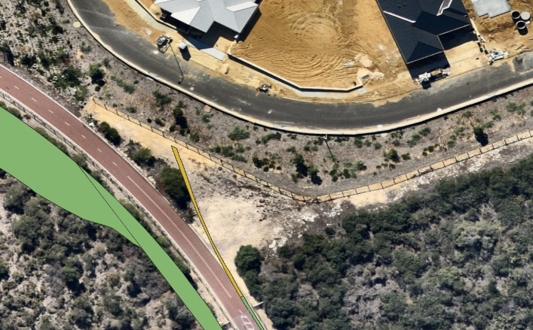
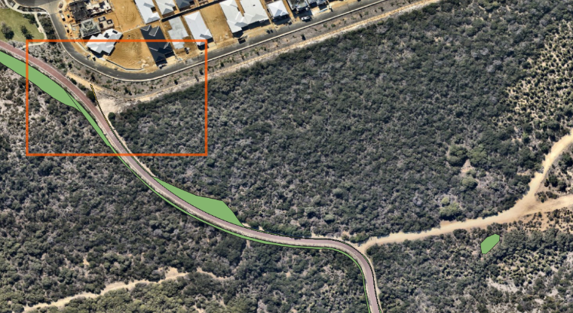

Figure 5A Northern section of the track – lower insert shows the area that has been from the reveg plan - as it was cleared for a firebreak. Refer to Figure 5B and Figure 5C for detils for the ammended area.

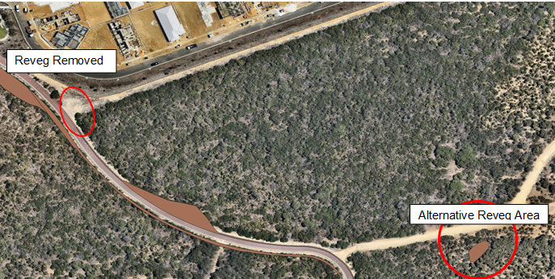
Figure 5B: Current revegetation area
The proposed revegetation area, as shown in Figure 5, is owned and managed by the Department of Planning, Lands and Heritage (DPLH). The offset proposal involves the removal of 0.002 hectares of vegetation from the offset site and the installation of an additional 0.011 hectares (Figure 5 – bottom right) on Lot 9505, DP 52070, Mindarie 6030.
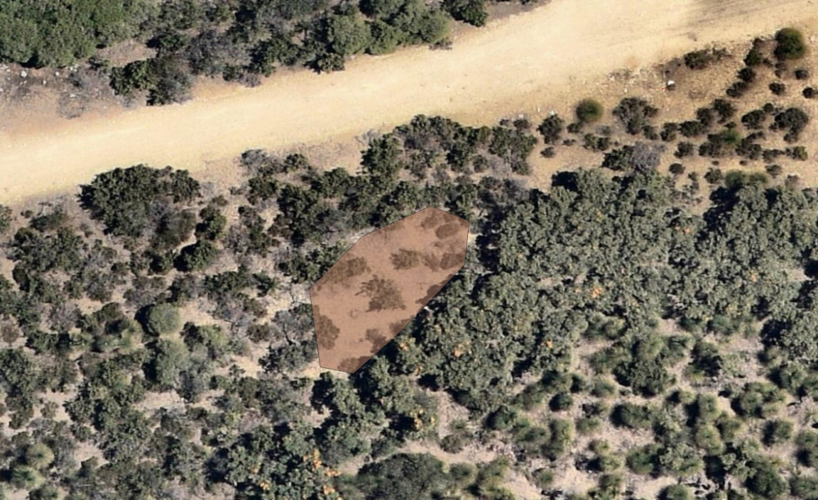Figure 5C: Proposed 0.011ha of revegetation. (MsLM veg type – this area will be planted and managed by CoW 2025)

Figure 5D - Southern section of DUP

Individual species lists have been developed for the 1.7ha of rehabilitation areas in order to align with each of the five different vegetation types. Whilst every effort has been made to replicate the species composition, the ratios vary slightly due to the practical challenges involved in recreating these vegetation types (i.e. ability to collect and/or propagate a species). The resulting revegetation species lists have therefore been slightly modified to ensure improved on-ground outcomes. These modifications are summarised in Table 4.

Table 4: Explanation of modifications to species lists to ensure improved rehabilitation outcomes
Reason for modification | Effected Vegetation Type
Acacia rostellifera is a dominant species which grow quickly. Planting these in close proximity to the path could result in a monoculture and high maintenance requirements, such as regular pruning. Hence the quantity of this species has been reduced. | SgAp  MsLm  ArLm
Acacia cyclops is a dominant species which grow quickly. Planting these in close proximity to the path could result in a monoculture and high maintenance requirements, such as regular pruning. Hence the quantity off this species has been reduced. | SgAp  MsLm  SgBm  OaCa
Lomandra preissii is hard to collect and propagate, therefore the availability of this plant is limited. A contingency of substituting Lepidosperma gladiatum will be used to provide soil stabilisation and erosion reduction to rehabilitation batters. | SgAp  MsLm  ArLm  SgBm  OaCa
Spinifex species (Spinifex longifolius) will be planted on the rehabilitation batters. Although this species was not identified within this vegetation type, it has been included to assist in stabilising the soil and reduce erosion from wind and rain, enabling other species to be able to transition into this area. This species has a slow growth rate and therefore is not likely to become a dominant species. | ArLm
A dominant species in this vegetation type is a weed (Briza maxima). Replicating this species in the rehabilitation would not be a good ecological outcome, so the species has been omitted from the rehabilitation list. | SgBm

Targets and Completion Criteria
This revegetation plan will be implemented over a three year period. The targets and completion criteria for the rehabilitation of the DUP eastern and western batters are outlined in Table 6 and have been developed to meet the objectives of the revegetation plan. Further detail and the timing of these actions are included in the schedule (Table 5).

Vegetation Establishment
Vegetation establishment in the revegetation area will occur by spreading topsoil, mulch and the planting of tube stock. Technical specifications detailing vegetation establishment techniques are included within Appendix C - Section 3.

There will be no direct seeding as part of this revegetation plan.

Seed Collection, Plant Salvage and Propagation
Local provenance species will be sourced from Tamala park and other reserves suitable for supplying the seed quantities required to meet completion criteria. To ensure sustainable collection practices, seed will be sourced from the following reserves:
- Tamala Park, Mindarie & Burns Beach, CoW and CoJ
- Longbeach Reserve, Quinns Rocks, CoW;
- Claytons Beach reserve, Mindarie, CoW;
- Burns Beach Reserve, Burns Beach, CoJ;
- Mindarie Foreshore, Mindarie, CoW;
- Quinns Rocks Foreshore, Quinns Rocks, CoW; and
- Yanchep Foreshore, Yanchep, CoW.

The timing of seed collection is detailed in the rehabilitation schedule (Table 5). The City of Wanneroo has engaged a contractor (certified by the Revegetation Industry Association of Western Australia (RIAWA) to undertake seed collection, plant salvage and propagation works. Seed collection and plant propagation will be carried out in accordance with the specifications outlined in Sections 1 and 2 of Appendix C.

Species’ lists for seed collection and propagation are provided in Table 6. The species lists have been developed using data collected from the biological survey and prior experience in developing and implementing revegetation projects.

A contractor (certified by the Revegetation Industry Association of Western Australia (RIAWA) will be engaged to salvage plants that are not able to be propagated commercially. It is intended that species of Zamia and Xanthorrhoea preissii will be salvaged from the approved DUP clearing areas (including the DUP construction extent) prior to clearing vegetation and taken to the nursery for storage and replanting. The salvaged plants will be planted in the revegetation area in Year 2 & 3.

Table 5: Rehabilitation Schedule
Stage | Action | Purpose |  | How |  | Responsibility | Compliance Criteria | Year 0  (2018/19) |  |  |  |  |  |  |  |  |  |  |  | Year 1  (2019/2020) |  |  |  |  |  |  |  |  |  |  |  | Year 2  (2020/21) |  |  |  |  |  |  |  |  |  |  |  | Year 3  (2021/22)
 |  |  |  |  |  |  |  | Jul | Aug | Sep | Oct | Nov | Dec | Jan | Feb | Mar | Apr | May | Jun | Jul | Aug | Sep | Oct | Nov | Dec | Jan | Feb | Mar | Apr | May | Jun | Jul | Aug | Sep | Oct | Nov | Dec | Jan | Feb | Mar | Apr | May | Jun | Jul | Aug | Sep | Oct | Nov | Dec | Jan | Feb | Mar | Apr | May | Jun
SITE PREPARATION | Weed management | Weed management before construction and topsoil removal will assist in reducing the amount of weeds that may spread from the project site and emerge from the topsoil. |  | Carry out weed management to target prominent weeds before construction commences. |  | CoW to engage weed contractor | Weed contractor invoices |  |  |  |  |  |  |  |  |  | ** |  |  |  |  |  |  |  | ** | ** | ** | ** | ** | ** |  | **
SITE PREPARATION | Initial Rubbish Removal | Waste should be lawfully removed and disturbance and handling of topsoil minimised during the construction and rehabilitation processes. Increased handling of topsoil could lead to an incremental loss of topsoil and reduced potential seed source for rehabilitation. |  | An inspection of the DUP construction extent will be completed prior to the commencement of construction to ensure that all waste is identified, hand-picked and removed. |  | CoW to engage contractor | Waste removal receipts and applicable controlled waste documentation |  |  |  |  |  |  |  |  | #
SITE PREPARATION | Seed Collection | Seed will be collected from the relevant vegetation communities to ensure completion criteria is achieved (species richness ) |  | Local provenance species will be sourced from Tamala park and other reserves suitable for supplying the seed quantities required to meet completion criteria |  | CoW to engage seed contractor | Seed collection and storage receipts |  |  |  |  |  |  |  |  |  |  |  |  |  |  |  |  |  |  |  |  |  |  |  |  |  |  |  |  |  |  |  |  |  |  |  |  |  |  | * | * | * | * | * | *
SITE PREPARATION | Plant Salvage | Some species are not able to be propagated commercially. |  | A certified RAIWA contractor will be engaged to salvage Zamia and Grasstree species from the approved DUP construction extent and replanted in Year 2 & 3. |  | CoW to engage RIAWA contractor | Receipts from contractor, photos of salvaged plants |  |  |  |  |  |  |  |  | # | #
SITE PREPARATION | Dieback Mitigation | Dieback could be introduced or spread from the construction extent, which could result in a significant threat to the vegetation. |  | The DUP scope of works and associated technical specification includes the requirement to not introduce or spread any declared pests, weeds or diseases in to or from the project area, as a result of the work performed by the contractor. This includes the cleaning of machinery prior to entering and leaving site. |  | Construction, seed and weed management contractors | Records verifying the requirements of pathogen and weed management, as required in the scope of works and technical specifications.
SITE PREPARATION | Demarcation of clearing area and vegetation types | Ensure compliance with the permitted clearing area and ensure the relevant materials are placed back onto the batters in the areas, and vegetation types, from which they were sourced. |  | The construction extent and each of the vegetation types that transect within the construction extent will be demarcated before clearing commences, as outlined in the tender document. |  | Contractor | Photographic evidence of demarcation of clearing footprint and topsoil stockpiles.  Surveyed area and shapefiles provided of total cleared area after completed works.
SITE PREPARATION | Installation of fencing and gates | Stop unauthorised access and ensure that clearing area is not exceeded. Fencing will protect the revegetation areas and adjacent bushland |  | Installation of fencing along DUP construction extent, in accordance with Appendix 2, Section 3. |  | Contractor | Photos of fencing.
SITE PREPARATION | Collect Mulch | Mulch will create a cover for the revegetation batters, is a useful method for collecting seed stock from the vegetation, and a sustainable method for disposing of the vegetation. |  | Vegetation will be trimmed and grubbed from each of the corresponding vegetation types and chipped into mulch, through the use of a vegetation chipping device. The mulch will be stockpiled for use in the revegetation of the batters. |  | Contractor | Mulch placed into respective vegetation types - marked out by flagging or signs. Photos of vegetation, chipper being used and mulch stockpiles.
SITE PREPARATION | Collect Topsoil | Topsoil is a valuable seed source and required for the revegetation of the batters. |  | After vegetation removal, the top 75 mm of the topsoil will be removed and stockpiled for later use in the revegetation of the batters. |  | Contractor | Topsoil placed into respective vegetation types - marked out by flagging or signs. Photos of topsoil stockpiles.
SITE PREPARATION | Construction | To ensure that the construction of the DUP is built in compliance with the clearing permit. |  | Prior to vegetation establishment, site preparation and protection activities will be undertaken in accordance with specifications outlined in Appendix C, Section 3. Specifications of the revegetation plan are built into the scope of work for the construction contractor. |  | CoJ in consultation with the CoW. | DUP Construction Scope of works
SITE PREPARATION | Construction |  |  | Ensure compliance with the conditions of the clearing permit and scope of work. |  | Contractor | On site inspections and evidence required as part of construction tender and scope of works.
SITE PREPARATION | Establish Quadrat in SgBm | The SgBm quadrat was burnt in the October 2018 during a prescription burn. A representative site is required to assess against the SgBm vegetation community. |  | Re-establish a SgBm quadrat for future assessment against completion criteria. |  | CoW to engage botanical contractor | Photos and location map of new SgBm quadrat. Awareness of this site provided to relevant land managers and key LGA stakeholders e.g.. Fire services
SITE PREPARATION | Plant propagation | Ensure species of the relevant vegetation communities are available for future planning and that the completion criteria are achieved. |  | Propagation of species from collected seed to enable the required vegetation to be planted to meet the completion criteria. |  | Revegetation contractor | Invoices, photos and records of propagation
VEGETATION ESTABLISHMENT | Spread Topsoil |  | Topsoil is a valuable seed source and required for the revegetation of the batters. | The topsoil will be spread onto the revegetation areas, in the corresponding vegetation types, along the eastern and western batters to a depth of 75 mm. | Construction Contractor |  | Topsoil placed onto respective batters in the relevant vegetation types - marked out by flagging or signs. Photos of topsoil on batters.
VEGETATION ESTABLISHMENT | Spread Mulch |  | Mulch will create a cover for the revegetation batters and is a useful method for collecting seed stock from the vegetation, preventing erosion on the batters and a sustainable method for disposing of the vegetation. | Mulch will be returned to the batters once the topsoil has first been spread and prior to the planting of tube stock. | Construction Contractor |  | Mulch placed onto respective batters in the relevant vegetation types - marked out by flagging or signs. Photos of mulch on batters.
VEGETATION ESTABLISHMENT | Planting of tube stock and salvaged plants |  | Planting of tube stock and salvaged plants will assist in stabilising the batters and assist in achieving the completion criteria. | Tube stock and salvaged plants will be established to meet the specified completion criteria, and in accordance with Appendix 2. | Revegetation contractor |  | Photos of planted revegetation sites
VEGETATION ESTABLISHMENT | Dieback Mitigation |  | Disease (such as dieback) could potentially be introduced to, or spread from, this project area. The introduction of disease could result in a significant threat to the vegetation. | The DUP scope of works and associated technical specification includes the requirement to not introduce or spread any declared pests, weeds or diseases in to or from the project area, as a result of the work performed by the contractor. This includes the cleaning of machinery prior to entering and leaving site. | Construction, seed and weed management Contractors |  | Records shall be kept by the contractor verifying the requirements of pathogen and weed management, as required in the scope of works and technical specifications.
VEGETATION ESTABLISHMENT | Watering |  | Watering the revegetation will be required to assist in the establishment of the plants. | As specified in Appendix 2 | Revegetation contractor |  | Contractor invoices
MONITORING | Weed management |  | To manage the potential recruitment of weeds over the rehabilitation maintenance period. | Monitor the emergence of weeds as part of the annual revegetation monitoring program. | Botanical Consultant |  | Weed monitoring results included in the annual monitoring report. |  |  |  |  |  |  |  |  |  |  |  |  |  |  |  |  |  |  |  |  |  |  |  |  |  |  | ** |  |  |  |  |  |  |  |  |  |  |  | **
MONITORING | Monitoring of revegetation site |  | To ensure that the revegetation site is complying with the completion criteria | Monitoring of the vegetation site each September to monitor compliance with the completion criteria and develop contingency for criteria not being achieved. | Botanical Consultant |  | Revegetation monitoring results included in the annual monitoring report. |  |  |  |  |  |  |  |  |  |  |  |  |  |  |  |  |  |  |  |  |  |  |  |  |  |  | ** |  |  |  |  |  |  |  |  |  |  |  | **
MAINTENANCE | Weed management |  | To manage the potential recruitment of weeds over the rehabilitation maintenance period. | Implement a weed management program (in accordance with specifications outlined in Appendix C, Section 3) throughout the year to effectively manage the emergence and spread of weeds. | Weed Management contractor |  | Weed contractor invoices |  |  |  |  |  |  |  |  |  |  |  |  |  |  |  |  |  |  |  |  |  |  |  |  | ** |  | ** |  |  |  |  |  | ** | ** | ** |  | ** |  | ** |  |  |  |  |  | ** | ** | **
MAINTENANCE | Watering |  | Where criteria listed in Table 7 are identified as ‘at risk’ of meeting targets, contingency measures such as remedial planting and watering will be implemented. | Maintenance activities will be undertaken where required over the three year period as outlined in Appendix C, Section 3. | CoW and revegetation contractor |  | Contractor invoices
MAINTENANCE | Plant propagation |  | Ensure species of the relevant vegetation communities are available for future planning and that the completion criteria are achieved. | Propagation of species from collected seed to enable the required vegetation to be planted to meet the completion criteria. | Revegetation contractor |  | Invoices, photos and records of propagation
MAINTENANCE | Remedial planting |  | Where criteria listed in Table 7 are identified as ‘at risk’ of meeting targets, contingency measures such as remedial planting and watering will be implemented. | Maintenance activities will be undertaken where required over the three year period as outlined in Appendix C, Section 3. | CoW and revegetation contractor |  | Contractor invoices  Photos
MAINTENANCE | Inspection of fencing and revegetation areas |  | Ensure measures are effective in managing potential impacts to the revegetation site and completion criteria are achieved. | Where criteria listed in Table 7 are identified as ‘at risk’ of meeting targets, contingency measures such as remedial planting and watering will be implemented. Maintenance activities will be undertaken where required over the three year period as outlined in Appendix C, Section 3. | CoW |  | Contractor invoices  Photos
MAINTENANCE | Maintenance of rubbish, fencing, signage and gates |  | Ensure measures are effective in managing potential impacts to the revegetation site and completion criteria are achieved. | Monthly rubbish and maintenance inspection and pickup | CoW |  | Contractor invoices  Photos
ONGOING | Dieback Mitigation |  | Dieback could potentially be introduced to. or spread from, this project area. The introduction of disease could result in a significant threat to the vegetation. | The scope of works and technical specification includes the requirement to not introduce or spread any declared pests, weeds or diseases in to or from the project area, as a result of the work performed by the contractor. This includes the cleaning of machinery prior to entering and leaving site. | Construction, seed and weed management Contractors |  | Records shall be kept by the contractor verifying the requirements of pathogen and weed management
ONGOING | Monitoring of unauthorised vehicles |  | Unauthorised vehicles cause damage and destruction of vegetation and exacerbate erosion of landscapes. | The activity of unauthorised vehicles will continue to be monitored throughout this project, with relevant actions implemented, as required. | Monitor project area - Construction Contractor and CoJ. Peet and Satterly manage unauthorised access from their respective developments |  | Evidence of implemented actions by the relevant party e.g.. Photos | As Required
REPORTING | Compliance report to DWER |  | Ensure the clearing permit conditions are complied with and that the revegetation is achieving the completion criteria. | Requirements of clearing permit are monitored and reported in an approved DoWER format | CoW |  | DoWER receive reports as required under Clearing Permit |  |  |  |  |  |  |  |  |  |  |  |  |  |  |  |  |  |  |  |  |  |  | # |  |  |  |  |  |  |  |  |  |  |  | # |  |  |  |  |  |  |  |  |  |  |  | #

Legend
* | Contingency - dependant on results of monitoring
** | Dependant on rainfall
# | Dependant on approvals

Table 6: Rehabilitation Species List
SPECIES | Plants Requiring Propagation
SPECIES | SgAp | MsLM | ArLm | SgBm | OaCa | TOTAL
Acacia cochlearis | 300 | 0 | 0 |  | 0 | 300
Acacia cyclops | 250 | 4200 | 0 | 300 | 900 | 5650
Acacia pulchella | 550 | 0 | 300 |  | 0 | 850
Acacia rostellifera | 1000 | 6700 | 700 |  | 0 | 8400
Acacia saligna | 250 | 800 | 0 |  | 500 | 1550
Acanthocarpus preissii | 1200 | 2400 | 500 | 500 | 400 | 5000
Atriplex isatidea | 550 | 0 | 0 |  | 0 | 550
Banksia sessilis var. cygnorum | 500 | 900 | 0 | 700 | 0 | 2100
Carpobrotus virescens | 0 | 3200 | 0 |  | 900 | 4100
Clematis linearifolia | 150 | 550 | 250 | 300 | 0 | 1250
Conostephium pendulum | 0 | 0 | 0 | 200 | 0 | 200
Conostylis aculeata | 0 | 0 | 0 |  | 500 | 500
Conostylis aurea | 500 | 0 | 0 |  | 300 | 800
Conostylis setigera | 400 | 1900 | 400 |  | 0 | 2700
Dianella revoluta | 0 | 700 | 0 | 300 | 0 | 1000
Eucalyptus gomphocephala | 0 | 0 | 100 |  | 0 | 100
Exocarpus sparteus | 0 | 0 | 0 |  | 700 | 700
Ficinia nodosa | 0 | 0 | 0 |  | 1200 | 1200
Gompholobium tomentosum | 300 | 0 | 0 |  | 0 | 300
Hakea lissocarpha | 0 | 800 | 0 |  | 0 | 800
Hardenbergia comptoniana | 500 | 2300 | 400 |  | 400 | 3600
Hemiandra pungens | 0 | 0 | 0 |  | 500 | 500
Hibbertia hypericoides | 0 | 1100 | 0 |  | 0 | 1100
Lepidosperma gladiatum | 1100 | 13000 | 2100 |  | 2600 | 18800
Leucopogon insularis | 0 | 0 | 0 |  | 200 | 200
Leucopogon parviflorus | 0 | 800 | 200 |  | 0 | 1000
Lomandra maritima | 900 | 1500 | 600 | 600 | 0 | 3600
Lomandra preissii | 0 | 0 | 0 | 300 | 0 | 300
Melaleuca cardiophylla | 0 | 700 | 0 |  | 0 | 700
Melaleuca huegelii | 0 | 0 | 0 | 700 | 0 | 700
Melaleuca systena | 700 | 2900 | 800 | 400 | 300 | 5100
Myoporum insulare | 0 | 0 | 0 |  | 600 | 600
Olearia axillaris | 650 | 3100 | 650 |  | 700 | 5100
Phyllanthus calycinus | 150 | 700 | 200 | 150 | 50 | 1250
Pimelea argentea | 0 | 0 | 300 |  | 0 | 300
Pimelea leucantha | 150 | 0 | 0 |  | 0 | 150
Rhagodia baccata subsp. Baccata | 950 | 2950 | 750 | 800 | 0 | 5450
Scaevola crassifolia | 0 | 0 | 0 |  | 1200 | 1200
Scaevola nitida | 0 | 0 | 800 |  | 0 | 800
Scaevola thesioides | 0 | 1900 | 400 |  | 0 | 2300
Spinifex longifolius | 0 | 0 | 1500 | 0 | 0 | 1500
Spyridium globulosum | 1200 | 4000 | 1400 | 450 | 450 | 7500
Templetonia retusa | 0 | 0 | 0 | 400 | 0 | 400
Xanthorrhoea preissii | 0 | 600 | 0 |  | 0 | 600

Topsoil and Mulch

The DUP construction extent and each of the vegetation types that transect within the construction extent will be demarcated before clearing commences. This will enable the contractor to stockpile mulch and topsoil material from each vegetation types in the marked corresponding area. This process assists with the relevant materials being placed back onto the batters in the areas, and vegetation types, from which they were sourced.

Vegetation will be trimmed and grubbed from each of the corresponding vegetation types and chipped into mulch, through the use of a vegetation chipping device. As described above, the mulch will be stockpiled and returned to the batters once the topsoil has first been spread (see Schedule – Table 5) the mulch will be spread over the revegetation area prior to the planting of tube stock.

The timing of topsoil and mulch spreading is provided in the schedule (Table 5). After vegetation removal has occurred within the DUP construction area, the top 75 mm of the topsoil will then be removed and stockpiled in accordance with the above-described practices. The topsoil will be spread onto the revegetation areas, in the corresponding vegetation types, along the eastern and western batters to a depth of 75 mm.

Whilst it is acknowledged that the topsoil may retain a source of weeds, it is not practical to remove the weed infested topsoil as the loss of native seed resource will be a far greater loss. It is more practical to establish a weed management program to target the prominent weed species and reduce the amount of weed seed source that may be stored in the topsoil. After the establishment of plants, a targeted weed program will take place to manage the potential recruitment of weeds over the rehabilitation maintenance period.

Euphorbia species were targeted and hand weeded in December 2018. Another prominent weed species, Pelargonium capitatum was also sprayed to mitigate the amount of weed seed that may be stored in the topsoil.

Table 7: Completion criteria, targets and monitoring for areas of revegetation
Criterion | Baseline floristic data | Completion targets | Completion criteria | Monitoring
1 | Species richness is  the average number  of species between  the reference  sites of each vegetation community . | Minimum of 50% of native vegetation species returned based on propagation capacity of species. Therefore  revegetation areas shall have a  minimum of 50% native species  per quadrat, as obtained by the  average recorded at the  reference sites. | Species richness  and number of  plants / m2 in the  revegetation areas  shall have a  minimum of 50% native species  per quadrat, as obtained by the  average recorded at the  reference sites. | The species and  number of plants /  m2 in the  revegetation areas  will be counted in  years 2 and 3.
2 | % cover of weeds in reference sites of each vegetation community is less 2%< to <30% | Weeds are mostly absent from the reference sites. Considering external pressures (adjacent to dual use path) a target of ≤10% has been established for the revegetation areas. | The revegetation  areas must have %  cover of ≤10%  weeds. | Monitor  revegetation areas  in years 2 and 3.
3 | One declared weed (*Asparagus asparagoides) is present | Declared Weeds are managed in accordance with the Biosecurity and Agriculture Management Regulations 2013. | Declared weeds are absent from the rehabilitation areas. | Monitor the  revegetation  site for declared  weeds by traversing  the area in years 2 and 3.
4 | Survival rate to be achieved | If after year 2 and year 3 of planting, a survival rate of 2plants/m² is not achieved, all planted tube stock that have not survived must be replanted within 12 months and monitored for a further 1 year. | The revegetation site needs to ensure a survival rate of at least 2 plants/m² is achieved after three years, and replant any plants within 12 months of dying. | The number of  surviving plants in  the revegetation areas will be counted in years 2 and 3.
5 | Rubbish is present in bushland. | Rubbish is absent from the revegetation site. | The revegetation site contains minimal rubbish. | Monthly asset inspections
Note: Structure criterion cannot be achieved due to a change in species substitution, as noted in Table 4.

Site Preparation and Protection
Prior to vegetation establishment, site preparation and protection activities will be undertaken in accordance with specifications outlined in Appendix C, Section 3. Weed treatment for the species listed in Table 2 will be undertaken in the revegetation area. A single rail conservation fence (as specified in the tender document and Section 3 of Appendix 2) will be installed along the DUP to protect the revegetation areas and adjacent bushland. The timing of site preparation activities are provided in the schedule (Table 5).

Maintenance
Maintenance activities will be undertaken following vegetation establishment and site protection activities to ensure measures are effective in managing the disturbances and threats at the revegetation site (Table 5) and criteria are on target for meeting completion criteria (Table 6). Post planting weed control will be undertaken in accordance with specifications outlined in Appendix C, Section 3. Where criteria listed in Table 7 are identified as ‘at risk’ of meeting targets, contingency measures such as remedial planting and watering will be implemented. Maintenance activities will be undertaken where required over the three year period as outlined in Appendix C, Section 3.

Schedule and Budget
A preliminary schedule (Table 5) has been developed for site preparation, vegetation establishment, monitoring, maintenance and reporting for the revegetation area. The City of Joondalup are responsible for implementing the construction and site preparation actions and will resource the revegetation and maintenance of the DUP utilising technical expertise from City of Wanneroo along with existing personnel and contractors. Timing of some actions may be dependent on project approval and schedules (i.e. spreading of topsoil). The schedule will be revised in accordance with project approvals and construction schedules.

A cost estimate for the revegetation and maintenance of the construction extent is provided in Table 8. The works will be funded through the City of Wanneroo, City of Joondalup and Western Australia State Government. When preparing the cost estimate, some assumptions have been made which include;
- Increase of CPI of 2.5% pa;
- Topsoil and mulch to be supplied free of charge, costs to spread only; and
- That funding will be available to commence seed collection in FY 2018/19 with revegetation activities following in subsequent financial years.

Table 8: Budget and Costings
Actions | Year 0 (18/19) | Year 1 (19/20) | Year 2  (20/21) |  | Year 3 (21/22) |  | Total
Weed management | $ 10,000.00 | $17,145.60 | $20,003.20 |  | $21,000.00 |  | $ 58,148.80
Fencing and gates  * $54.46/m for fencing and $1000 per gate x 4 | $ - | $ 264,000.00 | $ - |  | $ - |  | $ 264,000.00
Coir Mesh matting (13,500m²) | $ - | $ 124,200.00 | $ 15,100.00 |  | $ 22,650.00 |  | $ 161,950.00
Seed collection | $ 23,217.47 | $ 11,154.11 | $ 12,445.24 |  | $ - |  | $ 46,816.81
Salvage of plants and grasstrees | $ 2,500.00 | $ - | $ - |  | $ - |  | $ 2,500.00
Plant supply | $ - | $ 105,960.00 | $ 27,890.00 |  | $ 28,160.00 |  | $ 162,010.00
Planting of tube stock and salvaged plants | $ - | $114,975.00 | $ 32,000.00 |  | $ 30,712.00 |  | $ 177,687.00
Watering tubestock and grasstrees (6 applications) | $ - | $ - | $137,970.00 |  | $36,855.00 |  | $ 174,825.00
Monitoring of revegetation site | $ - | $ - | $ 8,000.00 |  | $ 8,000.00 |  | $ 16,000.00
Maintenance of rubbish, fencing, signage and gates | $ - | $9,600.00 | $10,200.00 |  | $10,800.00 |  | $ 30,600.00
 |  |  |  |  |  |  | $ 1,094,537.61

Monitoring and Analysis
Monitoring will be undertaken as outlined in Table 5 to ensure the criteria are on target and will inform contingency measures where required. An environmental specialist experienced in surveying and analysing flora and vegetation on the Swan Coastal Plain will be engaged to undertake monitoring. The specialist will be required to collect flora and vegetation data for analysis of species richness, number of surviving plants, weed coverage, presence of declared weeds and other potential impacts, as described in Section 4. A report shall be prepared in accordance with Appendix C of ‘A Guide to Preparing Revegetation Plans for Clearing Permits’ and provided to DWER as required by the clearing permit conditions (DWER, 2018).

Personnel will undertake an inspection of the revegetation site (asset inspection) every six months to ensure site protection measures (i.e. fencing) are providing the relevant functions to the revegetation site and identify any issues that require maintenance. Actions to rectify issues within the revegetation site will be implemented in a timely manner by raising work orders and/or engaging a contractor.

Timing for monitoring and reporting are outlined in the project schedule provided in Table 5.

References

AECOM.(2018) .Tamala Park Reserve - Biological Report

Bettinck & Keighery .(2008). Environment Weed Census and Prioritisation for the Swan NRM Region

City of Wanneroo .(2019). Customer Request Management

City of Wanneroo .(2019.) IntraMaps. Retrieved from
http://www.wanneroo.wa.gov.au/info/20017/planning_and_building/80/online_mapping

Department of the Environment and Energy. (2016). Approved Conservation Advice for the Banksia Woodlands of the Swan Coastal Plain Ecological Community. Commonwealth of Australia.

Department of Water and Environmental Regulation (DWER). (2018). A Guide to Preparing Revegetation Plans for Clearing Permits under Part V of the Environmental Protection Act 1986. Retrieved fromhttps://www.der.wa.gov.au/images/documents/our-work/consultation/Revegetation-plan/A_Guide_to_Preparing_Revegetation_Plans_for_Clearing_Permits.pdf Key document template - Guideline

GHD .( 2013). Proposed Dual Use Coastal Path between Mindarie and Burns Beach Environmental Study and Topographical Survey Report

Landgate .(2019). Map Viewer Plus. Retrieved from https://maps.landgate.wa.gov.au/maps-landgate/registered/

Nature Conservation Council of NSW. (2015). Primer on fire ecology. Retrieved from
https://www.nature.org.au/media/213630/fire-ecology-primer-v2-oct2015.pdf

Nearmap .(2019). Retrieved from http://maps.au.nearmap.com/

TPG .(2012). Tamala Park Local Structure Plan No. 79, Pert Two – Explanatory Report.

Western Australian Local Government Association. (2018) . Environmental Planning Tool.

Western Australian Local Government Association. (2004). Perth Biodiversity Project - Planning a Future for Perth’s Local Bushland, Wetlands and Other Natural Areas.

Western Australian Planning Commission. (2010). State Planning Policy 2.8 Bushland Policy for the Perth Metropolitan Region, Government of Western Australia.

Western Australia Planning Commission. (2012). The Tamala Conservation Park Establishment Plan

Appendices

Appendix A: Site Photos
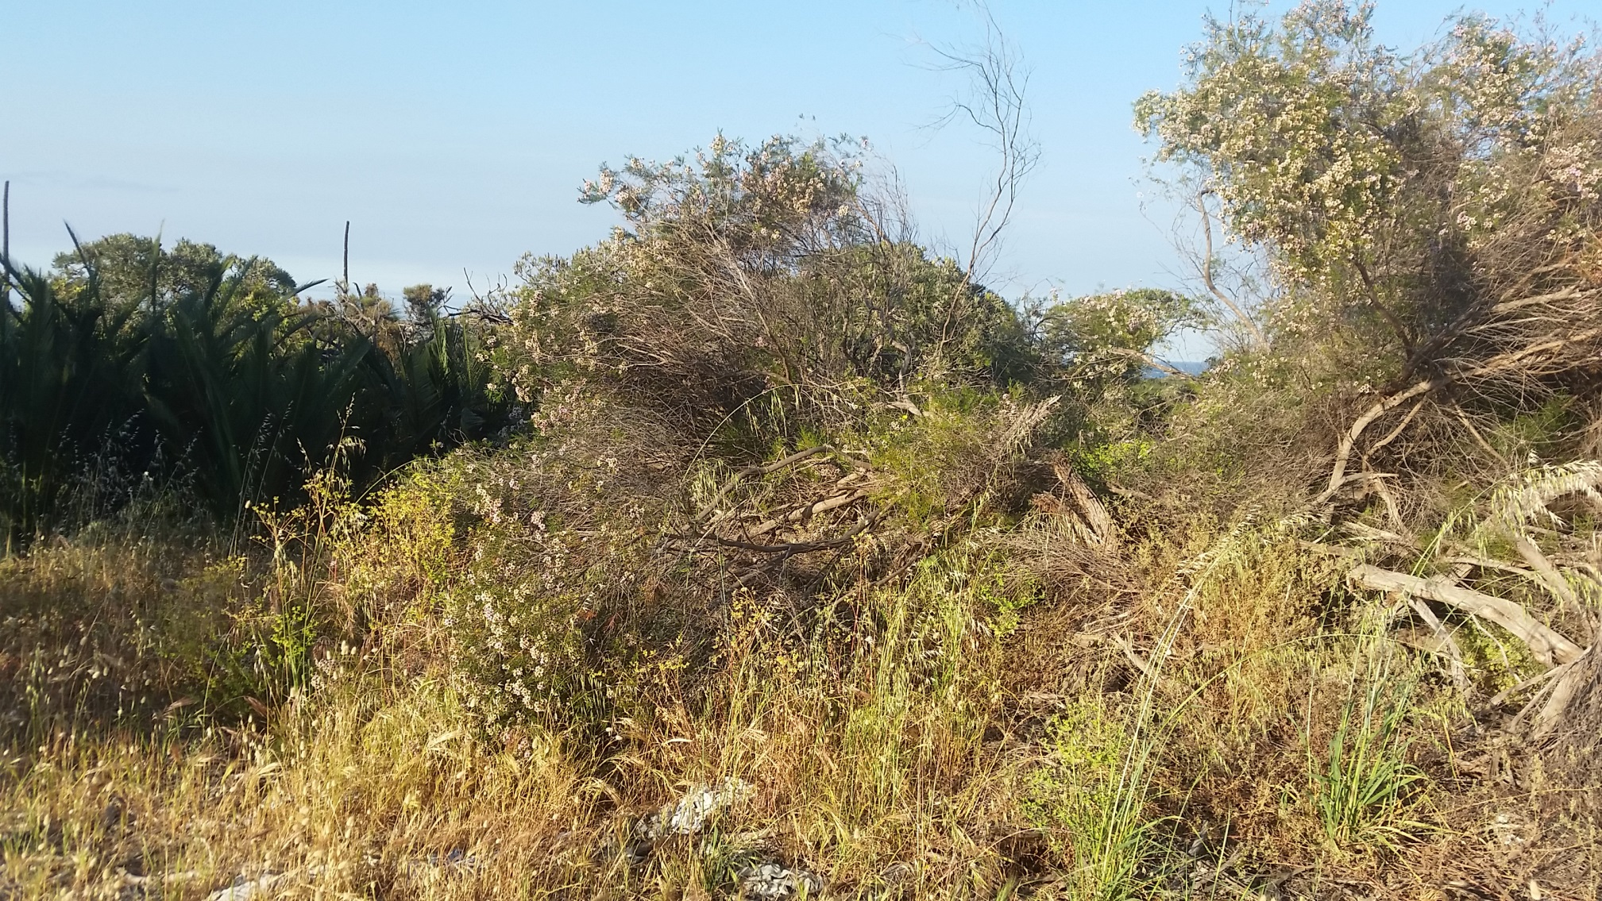
- Northern access track proposed for clearing (adajcent to Quadrat Q25) to allow improved machinery access from Marmion Avenue, looking west. Vegetation type - BaHhBm
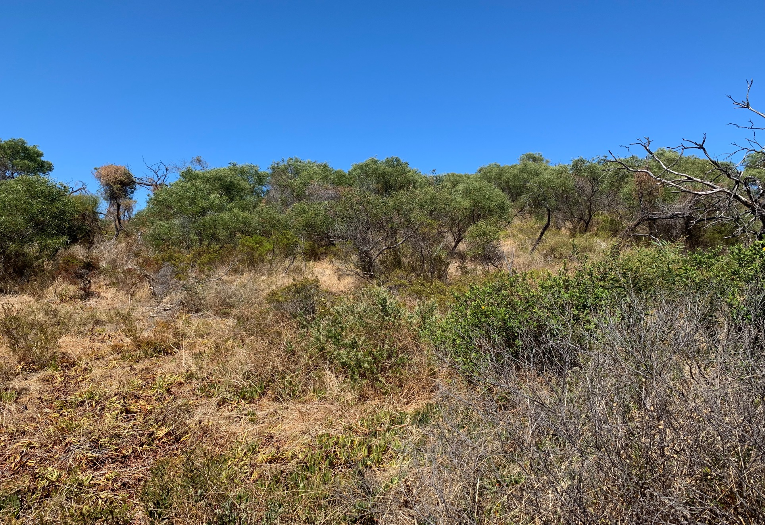
- Northern most component of DUP alignment (adajcent to Quadrat Tq03), looking west. Vegetation type - SgAp
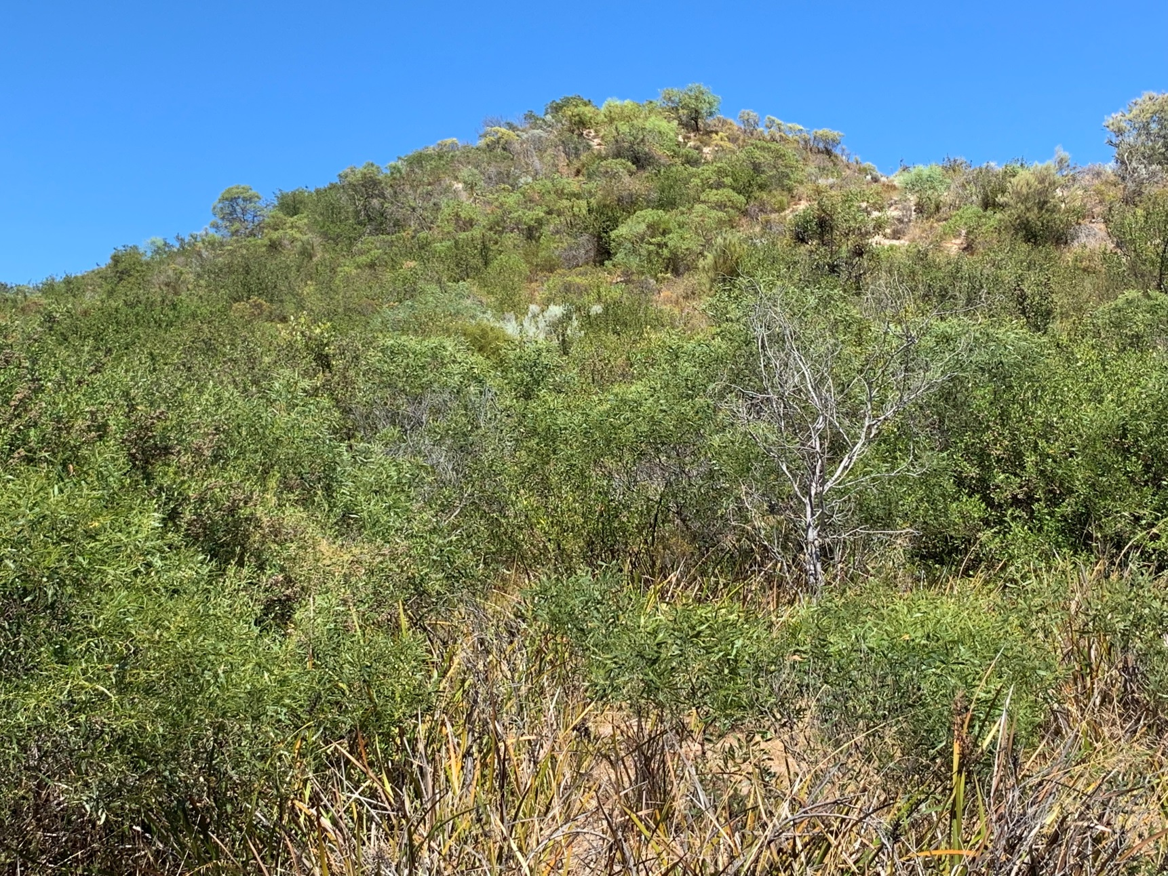
c) Northern component of DUP alignment (closest to Quadrat Q13), looking west. Vegetation type - MsLm
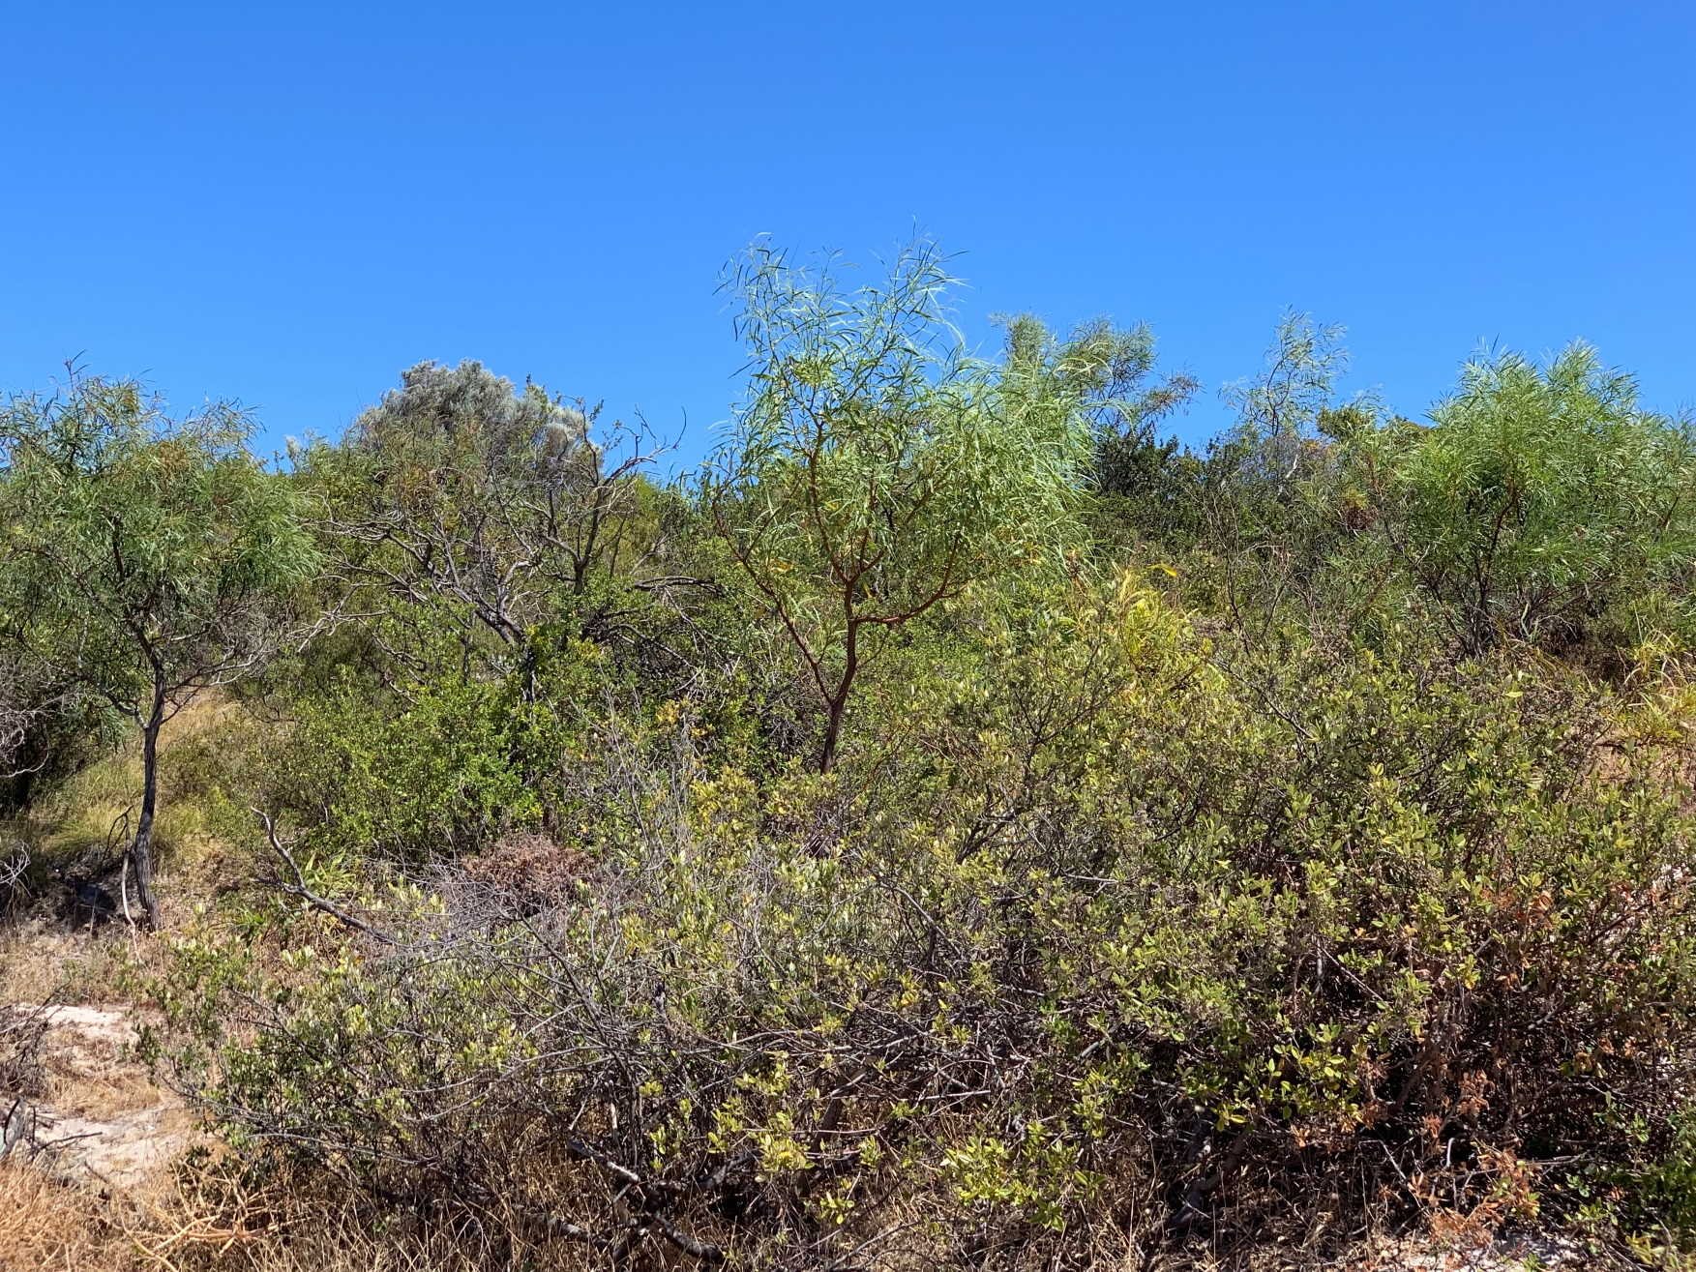
d) Central component of DUP alignment, at CoW and CoJ border, looking west. Vegetation type - MsLm
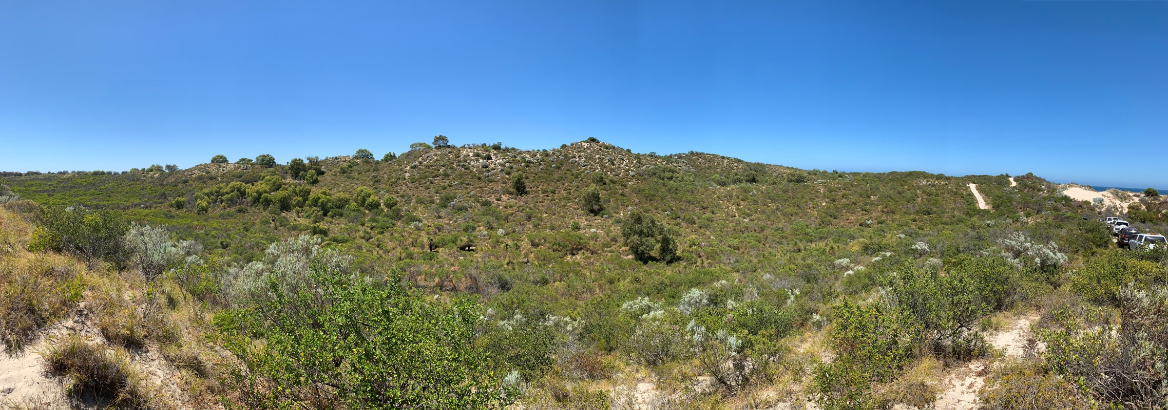 e) Southern component of DUP alignment (adajcent to Quadrat Tq10), looking south to south-east. Vegetation type - ArLm

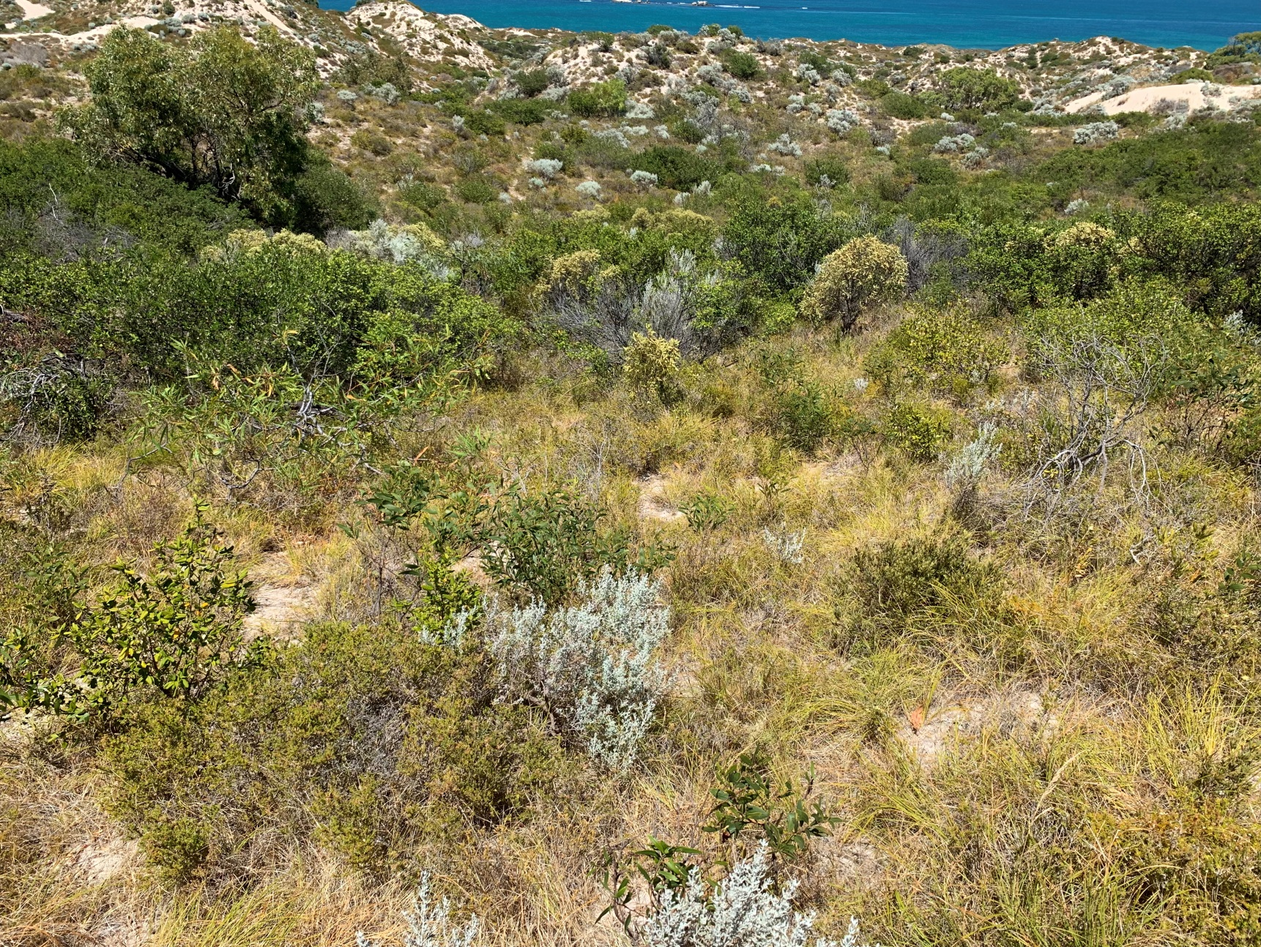
f) Southern most component of DUP alignment (adajcent to Releve Tr09), looking west. Vegetation type – ArLm

Appendix B: Biological Survey

Appendix C: Specifications

