Printed copies are uncontrolled unless marked otherwise. Refer to iRoads for current version.
D15#116511
July 2017

Offset Proposal - Financial Contributions
Brand Highway Widening and Passing Lane Package
March 2018

TRIM Document Number | D18#225602
Project Manager | Matthew Baker

Report Compilation & Review | Name and Position | Document Revision | Date
Author: | Emma Fitzgerald  Environment Officer | Rev 0 | 22/3/2018

Contents
1 PROJECT & OFFSET SUMMARY 1
1.1 Purpose 1
1.2 Project Location of Vegetation Clearing 2
1.3 Clearing Principles likely to be at Variance 15
1.4 Residual Impacts Associated With Specific Clearing Principles 15
2 OFFSET PROPOSAL REQUIREMENTS 17
2.1 Summary of Offset(s) Proposed 17
2.2 Justification for the Offset Proposal 19
2.3 Calculation of Financial Contribution 25
2.4 Offset Condition Milestones 25
3 APPLICATION OF ENVIRONMENTAL OFFSET POLICY PRINCIPLES 26
4 STAKEHOLDER CONSULTATION 27
5 REFERENCES AND RELATED DOCUMENTS 27
6 APPENDICES 29
Appendix A: EPBC Offset Calculator Tool 1

PROJECT & OFFSET SUMMARY
Project Location(s) | All the project locations are on Brand Highway:  Project type SLK range Shire  Widening 65-68.63 Gingin  71.02-74  77.3-79.84 Dandaragan  81.71-86  120-136  139-152  Northbound Passing Lane 34.83-36 Gingin  Southbound Passing Lane 68.63-71.02  Northbound Passing Lane 79.84-81.1 Dandaragan  Southbound Passing Lane 111.08-112.9  Northbound Passing Lane 113.6-115.94  Southbound Passing Lane 126.2-128.38  Northbound Passing Lane 159.8-163.6  Southbound Passing Lane 160.1-163.4  TOTAL
Project Details | Widening 65-68.63 SLK  This project will involve the widening of the road formation between 65 and 68.63 SLK to a seal/pavement configuration of 9m on 11m. This includes two 3.5m lanes, two 1m sealed shoulders and two 1m unsealed shoulders. To complete this work up to 2.2ha of native vegetation will be removed.  Start: Latitude: -31.0763  Longitude: 115.7524  End: Latitude: -31.0483  Longitude: 115.7332  Widening 71.02-74 SLK  This project will involve the widening of the road formation between 71.02 and 74 SLK to a seal/pavement configuration of 9m on 11m. This includes two 3.5m lanes, two 1m sealed shoulders and two 1m unsealed shoulders. To complete this work up to 1.8ha of native vegetation will be removed.  Start: Latitude: -31.0282  Longitude: 115.725  End: Latitude: -31.0038  Longitude: 115.7119  Widening 77.3-79.84 SLK  This project will involve the widening of the road formation between 77.3 and 79.84 SLK to a seal/pavement configuration of 9m on 11m. This includes two 3.5m lanes, two 1m sealed shoulders and two 1m unsealed shoulders. To complete this work up to 1.6ha of native vegetation will be removed.  Start: Latitude: -30.9765  Longitude: 115.6998  End: Latitude: -30.9569  Longitude: 115.6856  Widening 81.71-86 SLK  This project will involve the widening of the road formation between 81.71 and 86 SLK to a seal/pavement configuration of 9m on 11m. This includes two 3.5m lanes, two 1m sealed shoulders and two 1m unsealed shoulders. To complete this work up to 2.6ha of native vegetation will be removed.  Start: Latitude: -30.9431  Longitude: 115.6746  End: Latitude: -30.913  Longitude: 115.6465  Widening 120-136 SLK  This project will involve the widening of the road formation between 120 and 136 SLK to a seal/pavement configuration of 9m on 11m. This includes two 3.5m lanes, two 1m sealed shoulders and two 1m unsealed shoulders. To complete this work up to 6ha of native vegetation will be removed.  Start: Latitude: -30.6627  Longitude: 115.4665  End: Latitude: -30.5194  Longitude: 115.4634  Widening 139-152 SLK  This project will involve the widening of the road formation between 139 and 152 SLK to a seal/pavement configuration of 9m on 11m. This includes two 3.5m lanes, two 1m sealed shoulders and two 1m unsealed shoulders. To complete this work up to 4.6ha of native vegetation will be removed.  Start: Latitude: -30.4979  Longitude: 115.4793  End: Latitude: -30.384  Longitude: 115.4962  Northbound Passing Lane 34.83-36 SLK  This project involves the construction of a northbound passing lane and the widening of the existing road including shoulder widening on the southbound side of the road from 34.83-36 SLK. This will involve the clearing of up to 1.3ha of native vegetation.  Start: Latitude: -31.3098  Longitude: 115.8686  End: Latitude: -31.2992  Longitude: 115.8689  Southbound Passing Lane 68.63-71.02 SLK  This project involves the construction of a southbound passing lane and the widening of the existing road including shoulder widening on the northbound side of the road from 68.63-71.02 SLK. This will involve the clearing of up to 2.7ha of native vegetation.  Start: Latitude: -31.0484  Longitude: 115.7332  End: Latitude: -31.0281  Longitude: 115.7249  Northbound Passing Lane 79.84-81.1 SLK  This project involves the construction of a northbound passing lane and the widening of the existing road including shoulder widening on the southbound side of the road from 79.84-81.1 SLK. This will involve the clearing of up to 2.1ha of native vegetation.  Start: Latitude: -30.957  Longitude: 115.6856  End: Latitude: -30.943  Longitude: 115.6746  Southbound Passing Lane 111.08-112.9 SLK  This project involves the construction of a southbound passing lane and the widening of the existing road including shoulder widening on the northbound side of the road from 111.08-112.9 SLK. This will involve the clearing of up to 2.2ha of native vegetation.  Start: Latitude: -30.7265  Longitude: 115.5206  End: Latitude: -30.7139  Longitude: 115.5084  Northbound Passing Lane 113.6-115.94 SLK  This project involves the construction of a northbound passing lane and the widening of the existing road including shoulder widening on the southbound side of the road from 113.6-115.94 SLK. This will involve the clearing of up to 2.2ha of native vegetation.  Start: Latitude: -30.7089  Longitude: 115.504  End: Latitude: -30.6959  Longitude: 115.4904  Southbound Passing Lane 126.2-128.38 SLK  This project involves the construction of a southbound passing lane and the widening of the existing road including shoulder widening on the northbound side of the road from 126.2-128.38 SLK. This will involve the clearing of up to 2.5ha of native vegetation.  Start: Latitude: -30.6067  Longitude: 115.4666  End: Latitude: -30.5873  Longitude: 115.4631  Northbound Passing Lane 159.8-163.6 SLK and Southbound Passing Lane 160.1-163.4 SLK  This project involves the construction of a northbound passing lane between 159.8-163.3 SLK and the construction of a southbound passing lane between 160.1-163.4 SLK. The sections of road from 159.8-160.1SLK will be widened on the southbound side of the road and between 163.4 and 163.6SLK will be widened on the northbound side of the road. This will involve the clearing of 6ha of native vegetation.  Start: Latitude: -30.3199  Longitude: 115.471  End: Latitude: -30.2878  Longitude: 115.4756  Start: Latitude: -30.3172  Longitude: 115.4713  End: Latitude: -30.2895  Longitude: 115.4761  These works will be completed over several successive years as budgetary resources are made available starting in 2018.
Project Requirement | The works will provide safe passing opportunities and increase the functionality of the road.
Measures to avoid, reduce, mitigate and manage project impacts | - The clearing area will be demarcated prior to the commencement of project activities and prior to the commencement of native vegetation clearing.  - Further project clearing will be avoided as the site office, materials storage areas, construction vehicles/machinery and access tracks will be located on previously disturbed or cleared areas.  - The project design was refined to the smallest possible area.
Related Documents | An Environmental Impact Assessment (EIA)/ Environmental Management Plan (EMP) report of the project activities was completed. The assessment involved a desktop analysis of environmental aspects and impacts and a site investigation. A detailed assessment of native vegetation clearing impacts and assessment against the ten clearing principles are addressed in the Assessment Report (AR)/Vegetation Management Plan (VMP) report. A biological surveys were completed for this project; Astron 2016, GHD 2016, GHD 2016, Woodman targeted flora report 2017 and the Ecologia draft threatened ecological community mapping report 2018.  The AR determined that native vegetation clearing associated with the project activities was likely to be at variance with one or more of the ten clearing principles identified in the Environmental Protection Act1986.
Clearing Impacts | The AR determined native vegetation clearing associated with the project activities was  - May be at variance to Principle (a) as the project involves the removal of 22 priority flora species, 15.24ha of TEC and Carnaby’s Black Cockatoo foraging habitat  - At variance to Principle (b) as the project involves the removal of 34.29ha of foraging habitat and up to 51 potential breeding trees suitable for Carnaby’s Black Cockatoo.  - At variance to Principle (d) as the project involves the removal of up to 15.24ha of “Banksia Woodlands of the Swan Coastal Plain” Threatened Ecological Community.  - At variance to Principle (e) as the project involves the removal of 1.3ha of native vegetation that is considered significant as a remnant in an extensively cleared landscape  - At variance to Principle (f) as the project involves the removal of 0.27ha of riparian vegetation  - Not likely to be at variance to the remaining Clearing Principles.
Offset Type | Financial contribution to the Department of Water Environment Regulation (DWER) to mitigate significant residual impacts associated with the project activities.
Offset Purpose | - to offset significant residual impacts when project native vegetation clearing is at variance to one or more of the 10 clearing principles
Offset Requirement | When native vegetation clearing will be undertaken using Main Roads’ Statewide Purpose Clearing Permit CPS818/12 clearing activities must comply with specified permit conditions. When vegetation clearing impacts are assessed as likely to be at variance to one or more of the clearing principles an offset proposal is required to be prepared and implemented prior to the commencement of project activities unless an exemption has been obtained under condition 13c of CPS 818.  Condition 13 (d) of CPS818 requires the OP to be approved by the DWER prior to the commencement of project activities.  The offset proposal is required to offset vegetation values similar to that lost due to the brand Highway Package 2016/2017 clearing requirements via a financial contribution.
Offset Proposal | Main Road’s Offset Proposal is to provide $857, 100 for the purchase of approximately 172ha within the Shire of Gingin and Dandaragan to compensate for the significant residual impacts associated with the clearing of native vegetation for the road project. This money will be paid over consecutive years as funding for the projects becomes available as outlined below.  The Offset Proposal was developed using the EPBC Offset Calculator Tool (2012) to determine the area of the offset required in hectares, multiplied by the market valuation of the vegetated land within the Shire of Gingin and Dandaragan obtained from the Western Australian Valuer-General (2016).  Proposed Financial Year for construction Projects Offset Calculator Number Hectares purchased/Shire Offset cost Total Cost for financial year  2018/2019 Widening 120-136 SLK Package 1 19ha/Dandaragan $62, 700 $62, 700  Widening 139-152 SLK  2019/2020 Widening 65-68 SLK Package 2 part 1 25ha/Gingin $240, 500 $286, 900  Widening 71-74 SLK  Widening 77-79 SLK Package 2 part 2 8ha/Dandaragan $46, 400  Widening 81-86 SLK  2020/2021 Overtaking Lane 34-36 SLK Package 3 3ha/Gingin $50,730 $50, 730  2021/2022 Overtaking Lane 68-71 SLK Package 4 part 1 22ha/Gingin $211, 640 $267, 740  Overtaking Lane 79-81 SLK Package 4 part 2 17ha/Dandaragan $56, 100  2022/2023 Overtaking Lane 111-112 SLK Package 5 35ha/Dandaragan $115, 500 $115, 500  Overtaking Lane 113-115 SLK  2023/2024 Overtaking Lane 159-163 SLK Package 6 43ha/Dandaragan $75, 530 $73, 530

Purpose
The offset proposal is required to offset vegetation values similar to that lost due to the Brand Highway Passing Lanes and Widening Package clearing requirements via a financial contribution. The project is:
  - May be at variance to Principle (a) as the project involves the removal of 22 priority flora species, 15.24ha of TEC and Carnaby’s Black Cockatoo foraging habitat
  - At variance to Principle (b) as the project involves the removal of 34.29ha of foraging habitat and up to 51 potential breeding trees suitable for Carnaby’s Black Cockatoo.
  - At variance to Principle (d) as the project involves the removal of up to 15.24ha of “Banksia Woodlands of the Swan Coastal Plain” Threatened Ecological Community.
  - At variance to Principle (e) as the project involves the removal of 1.3ha of native vegetation that is considered significant as a remnant in an extensively cleared landscape
  - At variance to Principle (f) as the project involves the removal of 0.27ha of riparian vegetation
  - Not likely to be at variance to the remaining Clearing Principles.

Project Location of Vegetation Clearing
The road project location and vegetation clearing areas are shown in Figure 1-13.
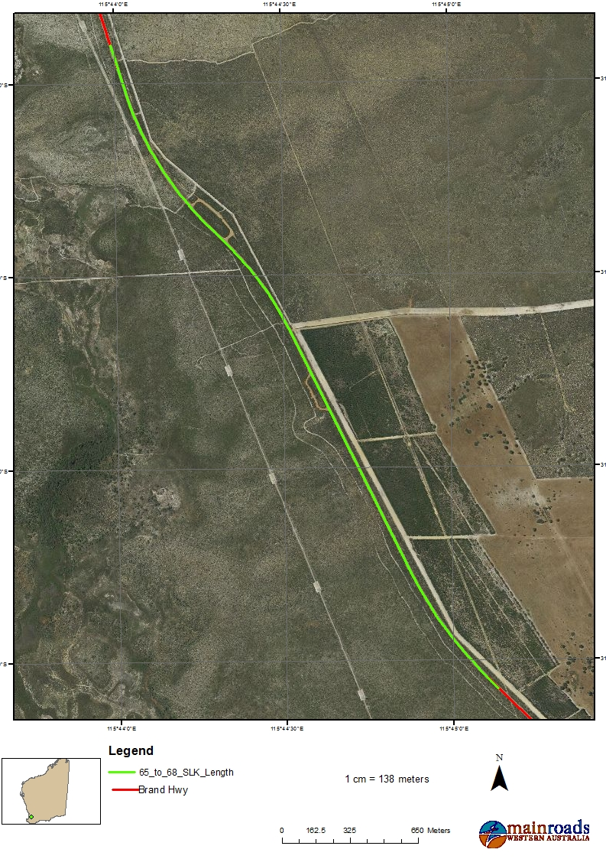
Figure 1 – Application Area Widening 65-68.63 SLK
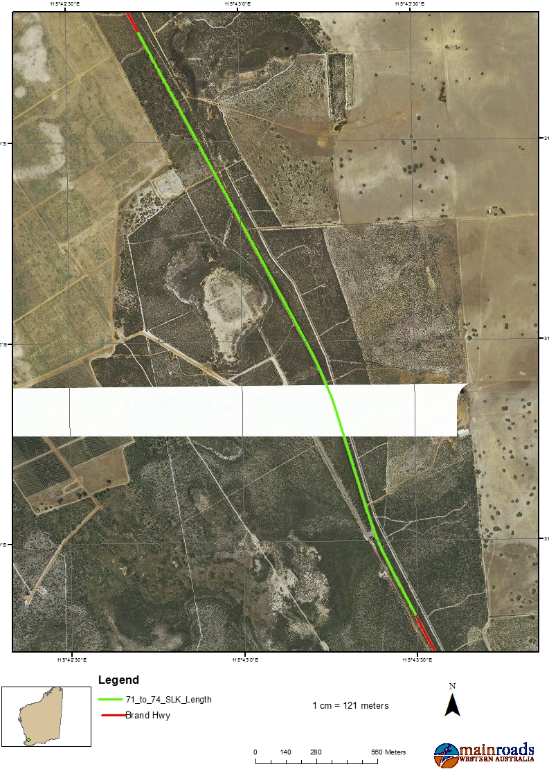
Figure 2 – Application Area Widening 71.02-74 SLK

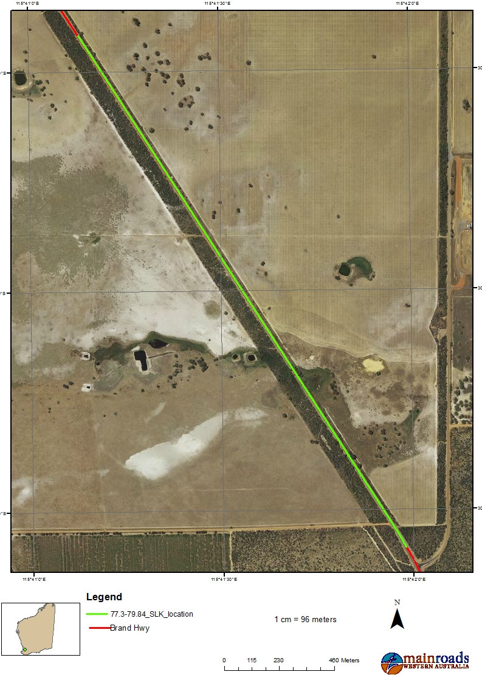
Figure 3 – Application Area Widening 77.3-79.84 SLK

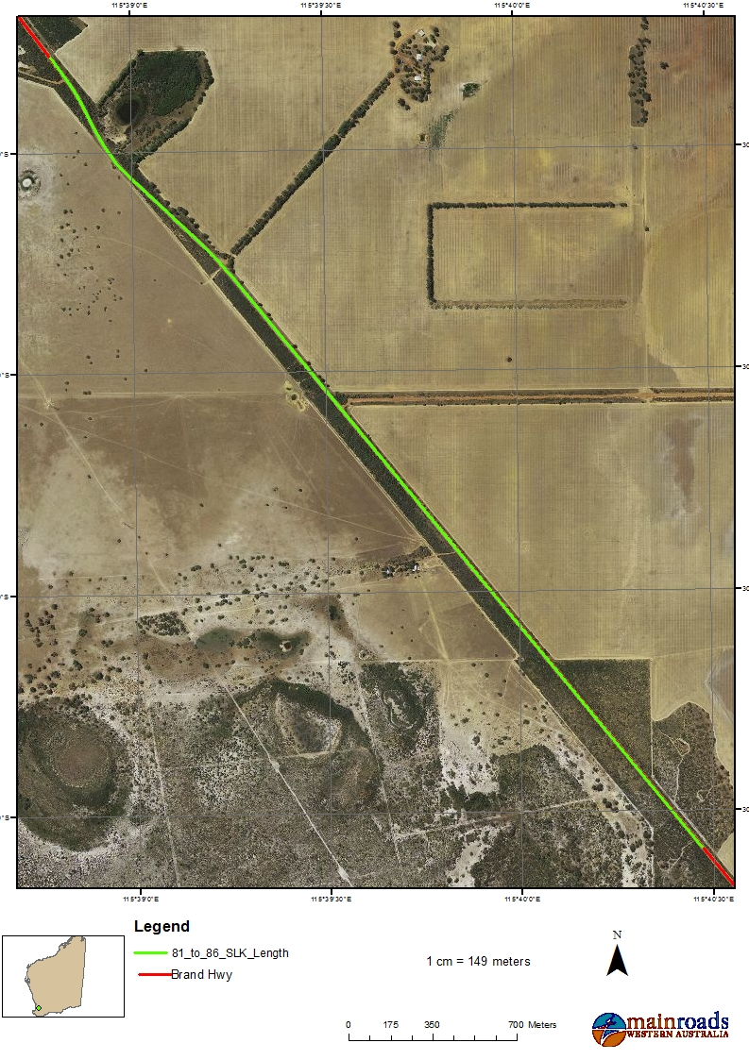
Figure 4 – Application Area Widening 81.71-86 SLK

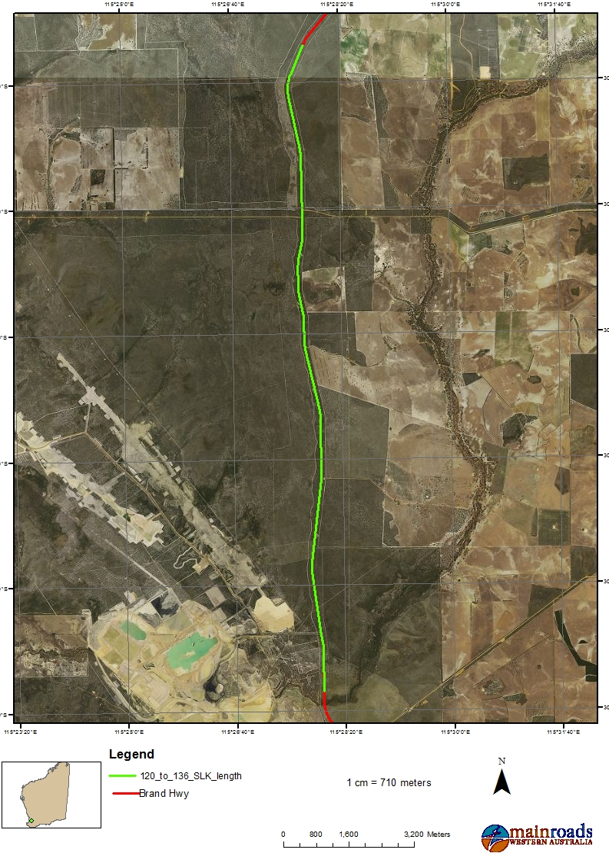
Figure 5 – Application Area Widening 120-136 SLK
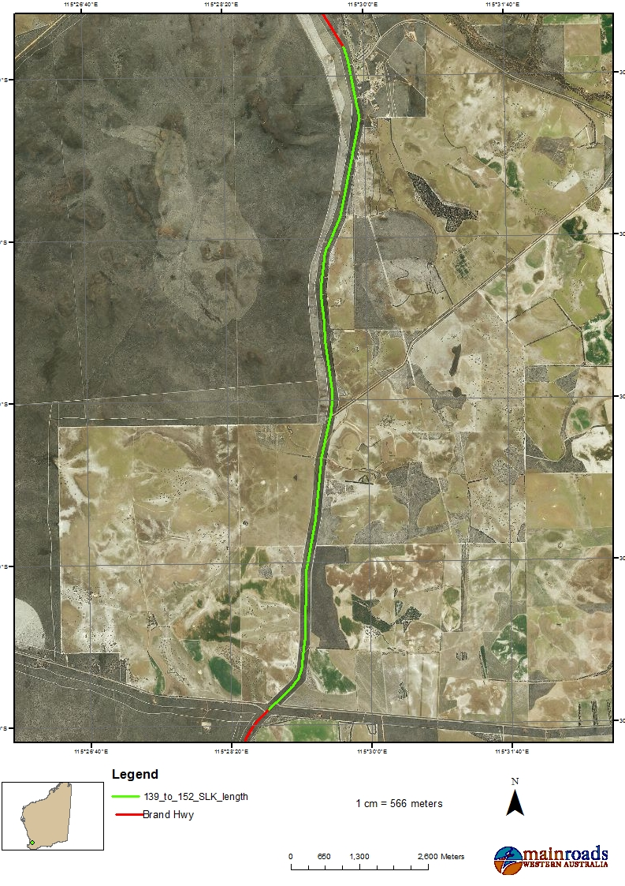
Figure 6– Application Area Widening 139-152 SLK
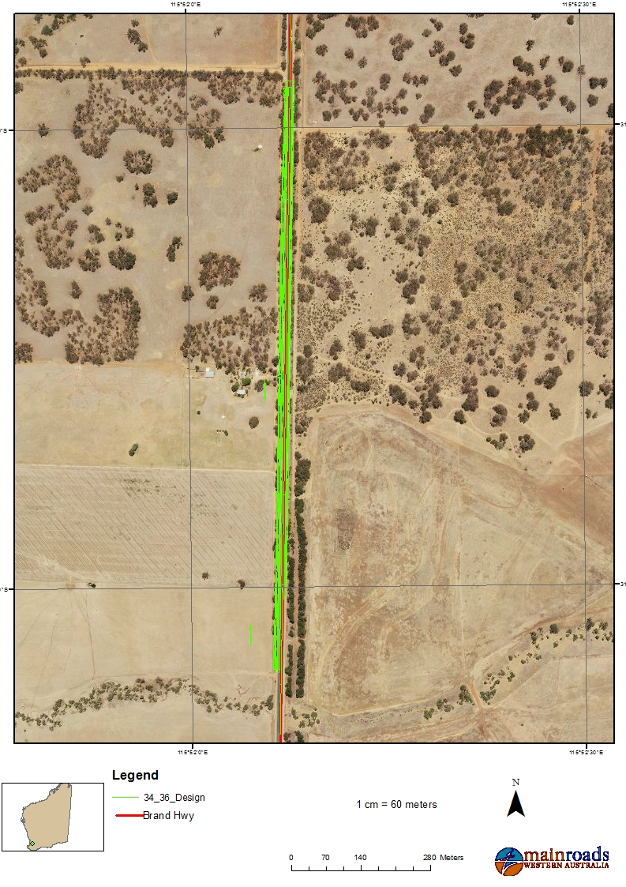
Figure 7 – Application Area Northbound Passing Lane 34.83-36 SLK
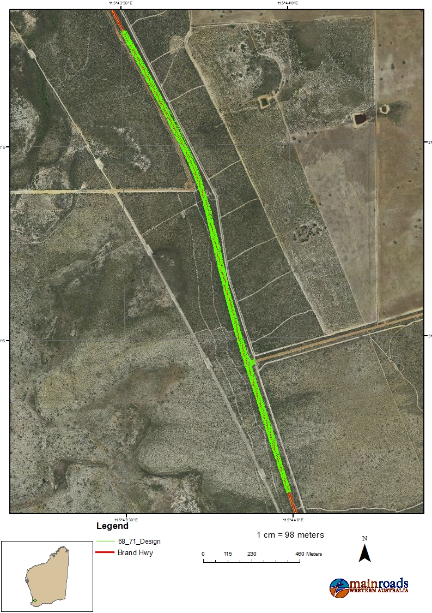
Figure 8 – Application Area Southbound Passing Lane 68.63-71.02 SLK

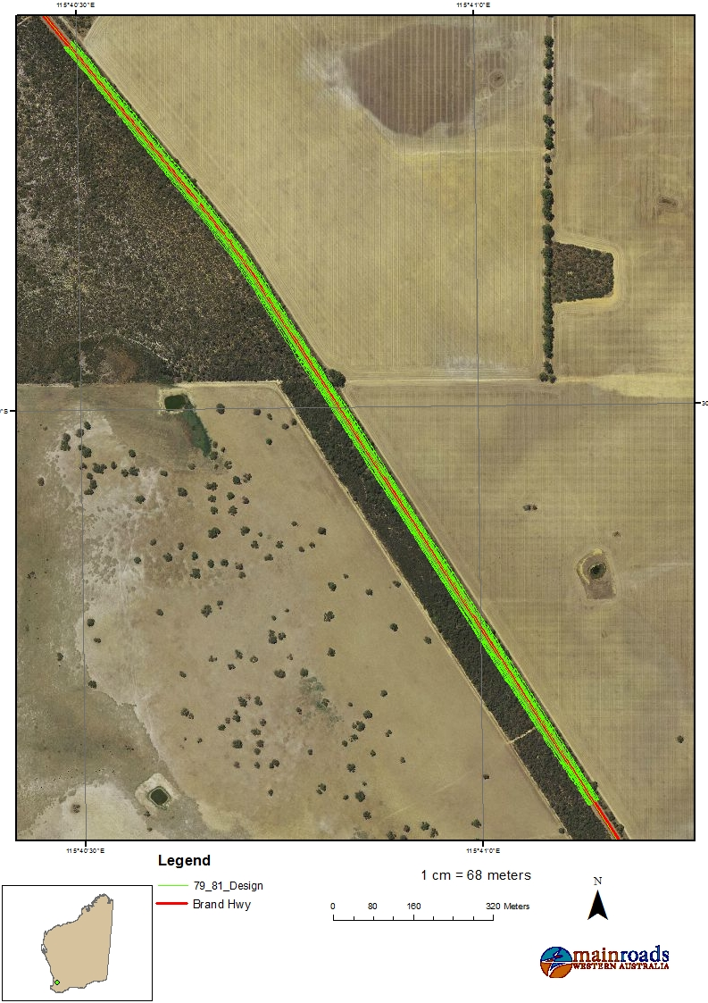
Figure 9 – Application Area Northbound Passing Lane 79.84-81.1 SLK

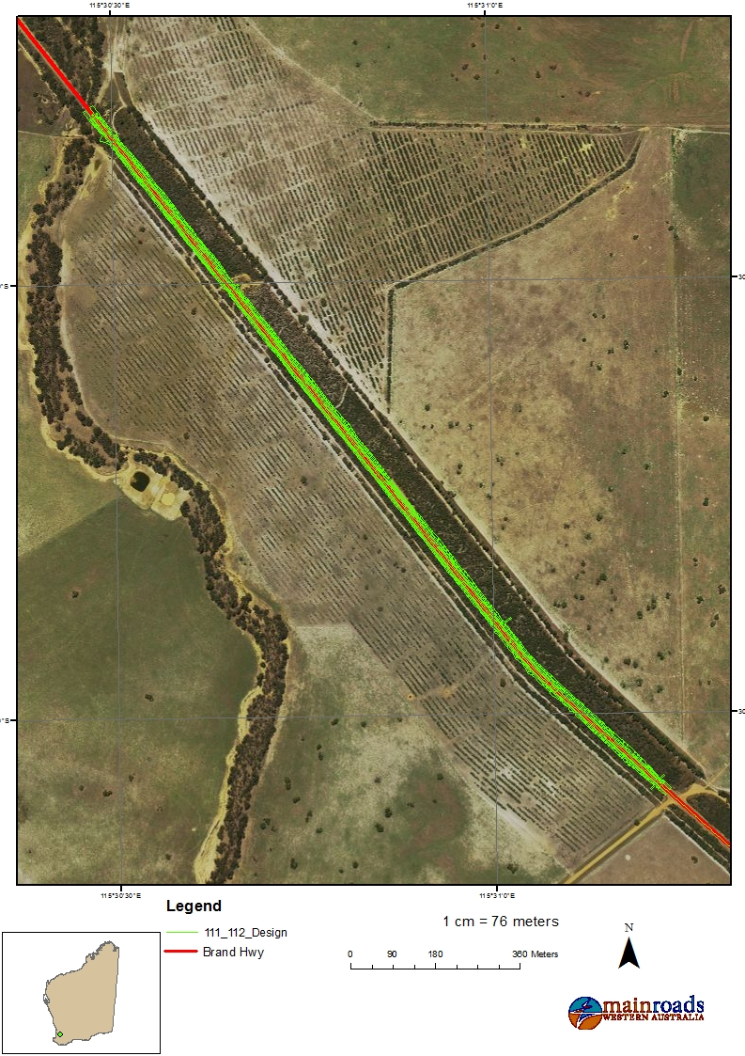
Figure 10– Application Area Southbound Passing Lane 111.08-112.9 SLK

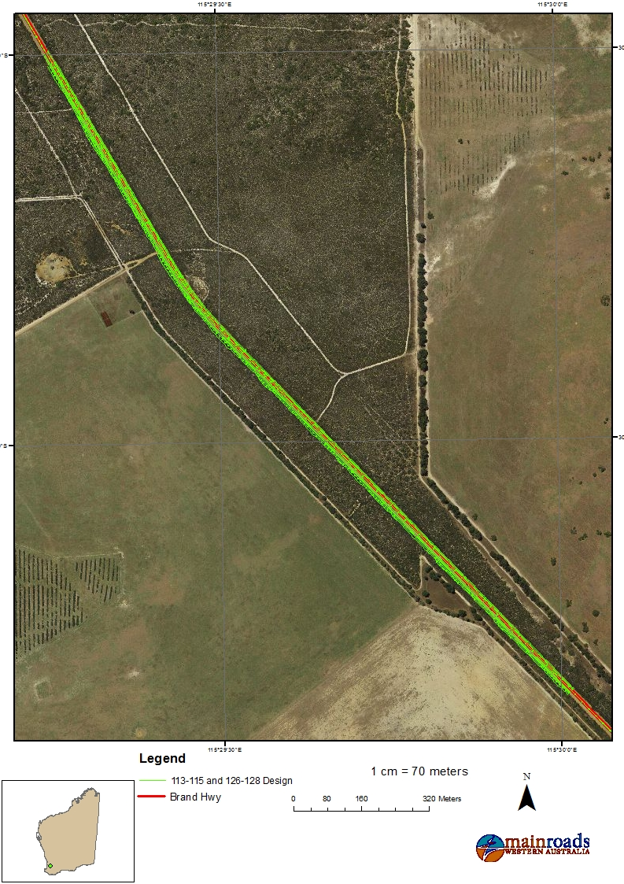
Figure 11 – Application Area Northbound Passing Lane 113.6-115.94 SLK

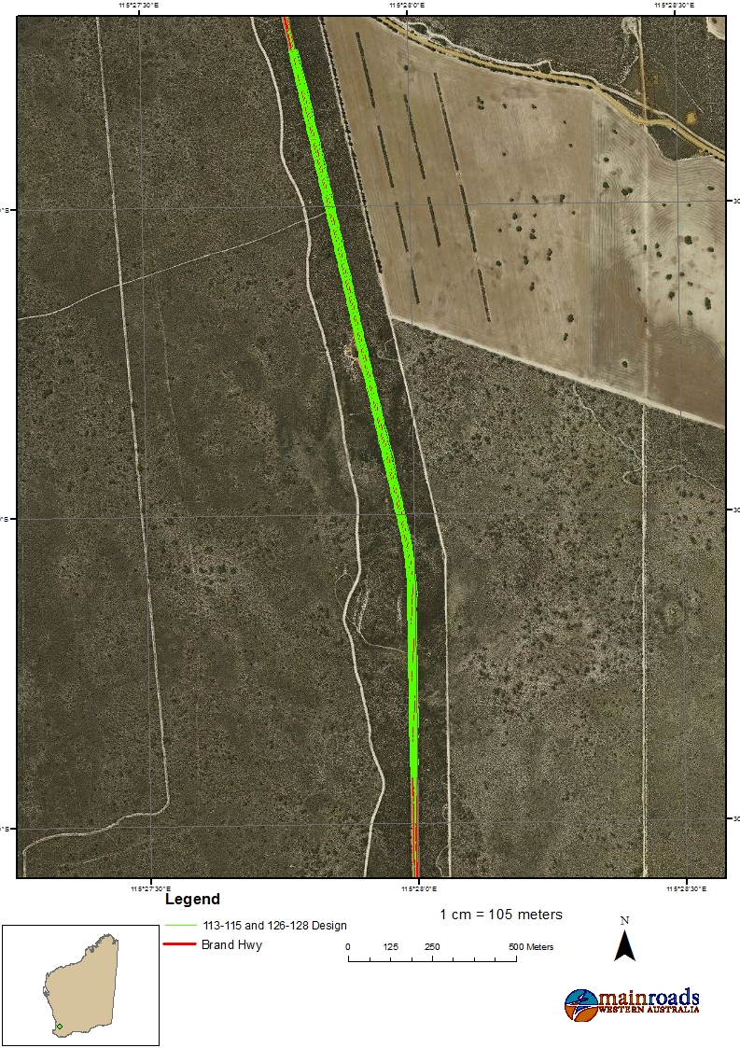
Figure 12 – Application Area Southbound Passing Lane 126.2-128.38 SLK

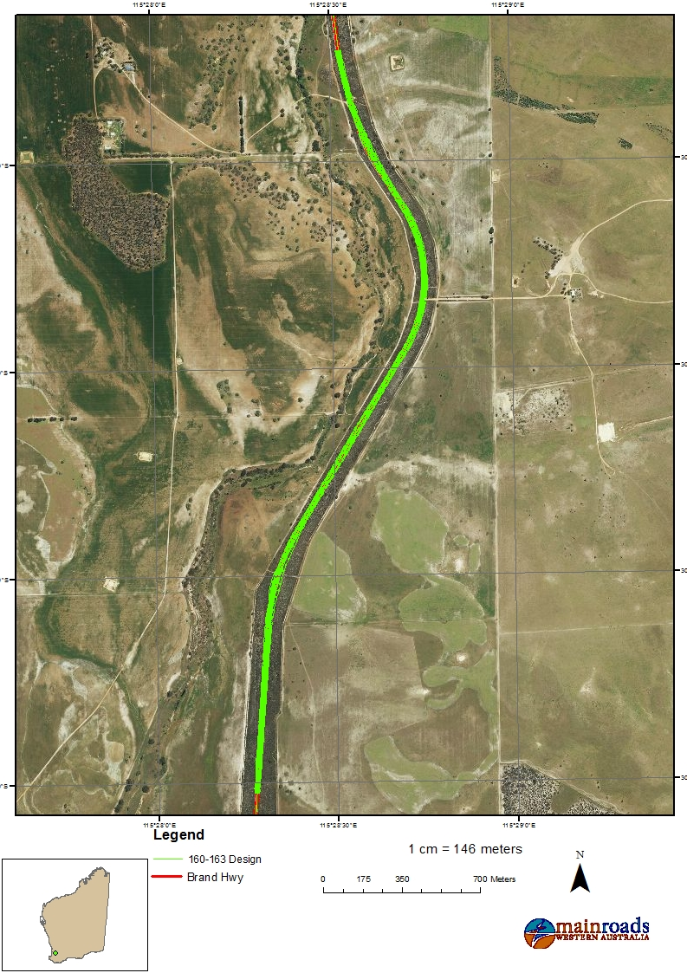
Figure 13 – Application Area Northbound Passing Lane 159.8-163.6 SLK and Southbound Passing Lane 160.1-163.4 SLK

Clearing Principles likely to be at Variance
The AR determined native vegetation clearing associated with the project activities was at variance to the following clearing principles:
- native vegetation should not be cleared if it comprises the whole or a part of, or is necessary for the maintenance of a significant habitat for fauna indigenous to Western Australia
- Native vegetation should not be cleared if it comprises the whole or a part of, or is necessary for the maintenance of a threatened ecological community
- Native vegetation should not be cleared if it is significant as a remnant of native vegetation in an area that has been extensively cleared
- Native vegetation should not be cleared if it is growing in, or in association with, an environment associated with a watercourse or wetland
And may be at variance to:
- native vegetation should not be cleared if it comprises a high level of biodiversity

Residual Impacts Associated With Specific Clearing Principles
The residual impacts associated with the project activities include the loss of 37.8ha of native vegetation. The vegetation condition is outlined below
Project | Condition
Widening 65-68.63 SLK and Northbound Passing Lane 79.84-81.71 SLK | Excellent to completely degraded (EPA and DPaW, 2015) condition with the majority in very good condition
Widening 71.02-74 SLK | Excellent to degraded (EPA and DPaW, 2015) condition with the majority in completely degraded condition
Widening 77.3-79.84 SLK, Widening 81.71-86 SLK, Widening 120-136 SLK and Widening 139-152 SLK | Excellent to completely degraded (EPA and DPaW, 2015) condition with the majority in completely degraded condition
Northbound Passing Lane 34.83-36 SLK | Degraded to completely degraded (EPA and DPaW, 2015) condition
Southbound Passing Lane 68.63-71.02 SLK | Excellent to completely degraded (EPA and DPaW, 2015) condition with the majority in very good to excellent condition
Southbound Passing Lane 111.08-112.9 SLK, Northbound Passing Lane 113.6-115.94 SLK and Southbound Passing Lane 126.2-128.38 SLK | Excellent to completely degraded (EPA and DPaW, 2015) condition with the majority being in excellent to very good condition
Northbound and southbound Passing Lane 159.8-163.6 SLK | Excellent to completely degraded (EPA and DPaW, 2015) condition with the majority in excellent condition

Clearing Principle (a)- Main Roads is proposing to remove 22 priority flora species, 15.24ha of TEC and Carnaby’s Black Cockatoo foraging habitat
Given the priority flora impacts are not significant in a local or population context, Main Roads will be requesting an exemption from providing an offset for priority flora.

Clearing Principle (b)-Main Roads is proposing to clear 34.29ha of foraging habitat and up to 51 potential breeding trees suitable for Carnaby’s Black Cockatoo.
Clearing Principle (d)-Main Roads is proposing to clear 15.24ha of vegetation that represents the Banksia Woodlands of the Swan Coastal Plain TEC.

Clearing Principle (e)- Main Roads is proposing to removal 1.3ha of native vegetation that is considered significant as a remnant
Due to the small area of clearing and low residual impact, Main Roads will be requesting an exemption from providing an offset for this Principle.

Clearing Principle (f)- Main Roads is proposing to remove 0.27ha of riparian vegetation
Given the small amount of clearing of vegetation growing in association with a wetland or riparian area, along an existing road, there is low potential for significant residual impacts; Main Roads will be requesting an exemption from providing an offset.

OFFSET PROPOSAL REQUIREMENTS

Summary of Offset(s) Proposed
Main Roads’ Offset Proposal is to provide $859,100 for the purchase of approximately 172ha within the Shire of Gingin and Dandaragan to compensate for the significant residual impacts associated with the clearing of native vegetation for the road project. This offset will be paid in six separate packages to align with the delivery/financial schedule as outlined below.
Proposed financial year for construction | Projects | Offset Calculator Number | Hectares purchased/Shire | Offset cost | Total Cost for financial year
2018/2019 | Widening 120-136 SLK | Package 1 | 19ha/Dandaragan | $62, 700 | $62, 700
 | Widening 139-152 SLK
2019/2020 | Widening 65-68 SLK | Package 2 part 1 | 25ha/Gingin | $240, 500 | $286, 900
 | Widening 71-74 SLK
 | Widening 77-79 SLK | Package 2 part 2 | 8ha/Dandaragan | $46, 400
 | Widening 81-86 SLK
2020/2021 | Overtaking Lane 34-36 SLK | Package 3 | 3ha/Gingin | $50,730 | $50,730
2021/2022 | Overtaking Lane 68-71 SLK | Package 4 part 1 | 22ha/Gingin | $211, 640 | $267, 740
 | Overtaking Lane 79-81  SLK | Package 4 part 2 | 17ha/Dandaragan | $56, 100
2022/2023 | Overtaking Lane 111-112 SLK | Package 5 | 35ha/Dandaragan | $115, 500 | $115, 500
 | Overtaking Lane 113-115 SLK
2023/2024 | Overtaking Lane 159-163 SLK | Package 6 | 43ha/Dandaragan | $73, 530 | $73, 530
TOTAL |  |  |  |  | $857, 100

A summary of the offset proposed is provided in Table 1 below.

Table 1. Summary of Residual Impacts, Offset Type, Size of Offset and Percentage of Residual Impact Offset.

Package |  | Residual Impact | Revegetation mitigation for temporary clearing applicable? (Y/N) | Offset Type (Other) | *Size of offset applicable to residual impact (ha) | % of residual impact offset
1 | Loss of moderate biodiversity vegetation including priority flora species |  | N | Financial Contribution to a fund established by DWER | 19 ha | 101.66
1 | Loss of 10.6ha of potential foraging habitat and 1 potential breeding tree |  | N | Financial Contribution to a fund established by DWER | 19ha | 101.66
2 part 1 | Loss of 4 of potential foraging habitat |  | N | Financial Contribution to a fund established by DWER | 25 ha | 101.28
2 part 1 | Loss of 4 of Banksia Woodland of the Swan Coastal Plain TEC |  | N | Financial Contribution to a fund established by DWER | 25 ha | 101.28
2 part 2 | Loss of 4.2 of potential foraging habitat |  | N | Financial Contribution to a fund established by DWER | 8 ha | 108.03
2 part 2 | Loss of 4.2 of Banksia Woodland of the Swan Coastal Plain TEC |  | N | Financial Contribution to a fund established by DWER | 8 ha | 108.03
3 | Loss of 0.96ha of potential foraging habitat and 50 potential breeding trees. |  | N | Financial Contribution to a fund established by DWER | 3ha | 118.16
3 | Loss of vegetation which is significant as a remnant |  | N | Financial Contribution to a fund established by DWER | 3ha | 118.16
4 part 1 | Loss of 2.7ha of potential foraging habitat |  | N | Financial Contribution to a fund established by DWER | 22ha | 102.7
4 part 1 | Loss of 2.7ha of Banksia Woodland of the Swan Coastal Plain TEC |  | N | Financial Contribution to a fund established by DWER | 22ha | 102.7
4 part 2 | Loss of 2.1ha of potential foraging habitat |  | N | Financial Contribution to a fund established by DWER | 17ha | 102.03
4 part 2 | Loss of 2.1ha of Banksia Woodland of the Swan Coastal Plain TEC |  | N | Financial Contribution to a fund established by DWER | 17ha | 102.03
5 | Loss of 4.4ha of potential foraging habitat |  | N | Financial Contribution to a fund established by DWER | 35ha | 100.26
5 | Loss of 2.2ha of Banksia Woodland of the Swan Coastal Plain TEC |  | N | Financial Contribution to a fund established by DWER | 35ha | 100.26
6 | Loss of 5.33ha of potential Black Cockatoo foraging habitat |  | N | Financial Contribution to a fund established by DWER | 43ha | 101.68

Justification for the Offset Proposal
The EPBC Offset Calculator Tool was used to evaluate project impacts for biodiversity clearing principles (principles a - f, h) with significant residual impacts in accordance with the requirements of the WA Environmental Offsets Guidelines (WA Govt., 2014). The values input into the EPBC Offset Calculator Tool for the significant residual impacts for Clearing Principle (b) is provided in Table 2-9.

Table 2. Values that were Input into the EPBC Calculator Tool – Residual Impact to Clearing Principle b-Package 1

Attribute | Value | Justification
Area of community/habitat impacted | 10.6 ha | Loss of 10.6ha of potential foraging habitat and 1 potential breeding tree
Vegetation/Habitat quality of the impacted area (takes into account the regional context and stocking rate) | 2 | The biological surveys indiacte the vegetation is in excellent to completely degraded condition with the majority of the project area in completely degraded (EPA and DPaW, 2015) condition.  Located in an area with large parcel of intact vegetation in good quality condition in the nearby conservation area.
Start quality Vegetation/habitat Quality of the offset area (takes into account the regional context and stocking rate) | 8 | Rating for Excellent condition vegetation based on Keighery (1994). It is assumed that land purchase with funds provided under s51i (2b) of the EP Act (1986) would be in Excellent or Very Good condition (Keighery, 1994).
Future Quality without Offset | 8 | Unlikely to change over a period of one year
Future Quality with Offset | 8 | Acquisition only therefore no change
Time Horizon over which loss is averted (security of land tenure) | 20 years | Land purchased with financial contributions will be added to the conservation estate so long term protection is afforded. Twenty years is the maximum value that can be input.
Time until ecological benefit | 1 year | Short time-frame required for land to be purchased and placed into the conservation estate.
Risk of loss without offset | 30% | Moderate risk of loss.
Risk of loss with offset | 10% | Minimal risk. Offset placed into secure tenure managed by the State (i.e. conservation estate). Ten percent allows for ongoing management of the offset site.
Confidence in result | 90% | High degree of confidence. Financial contributions are used to purchase land that is added to the conservation estate through a State guaranteed scheme.

Table 3. Values that were Input into the EPBC Calculator Tool – Residual Impact to Clearing Principle b-Package 2 part 1

Attribute | Value | Justification
Area of community/habitat impacted | 4 ha | Loss of 4 of potential foraging habitat
Vegetation/Habitat quality of the impacted area (takes into account the regional context and stocking rate) | 7 | The biological surveys indiacte the vegetation is in excellent to completely degraded condition with the majority of the project area in very good (EPA and DPaW, 2015) condition.  Located in an area with large parcel of intact vegetation in good quality condition in the nearby conservation area.
Start quality Vegetation/habitat Quality of the offset area (takes into account the regional context and stocking rate) | 8 | Rating for Excellent condition vegetation based on Keighery (1994). It is assumed that land purchase with funds provided under s51i (2b) of the EP Act (1986) would be in Excellent or Very Good condition (Keighery, 1994).
Future Quality without Offset | 8 | Unlikely to change over a period of one year
Future Quality with Offset | 8 | Acquisition only therefore no change
Time Horizon over which loss is averted (security of land tenure) | 20 years | Land purchased with financial contributions will be added to the conservation estate so long term protection is afforded. Twenty years is the maximum value that can be input.
Time until ecological benefit | 1 year | Short time-frame required for land to be purchased and placed into the conservation estate.
Risk of loss without offset | 30% | Moderate risk of loss.
Risk of loss with offset | 10% | Minimal risk. Offset placed into secure tenure managed by the State (i.e. conservation estate). Ten percent allows for ongoing management of the offset site.
Confidence in result | 90% | High degree of confidence. Financial contributions are used to purchase land that is added to the conservation estate through a State guaranteed scheme.

Table 4. Values that were Input into the EPBC Calculator Tool – Residual Impact to Clearing Principle b-Package 2 part 2

Attribute | Value | Justification
Area of community/habitat impacted | 4.2ha | Loss of 4.2ha of potential foraging habitat for Carnaby’s Black Cockatoo
Vegetation/Habitat quality of the impacted area (takes into account the regional context and stocking rate) | 2 | The biological surveys indiacte the vegetation is in excellent to completely degraded condition with the majority of the project area in completely degraded (EPA and DPaW, 2015) condition.  Located in an area with intact vegetation in good quality condition in theremainder of the road reserve.
Start quality Vegetation/habitat Quality of the offset area (takes into account the regional context and stocking rate) | 8 | Rating for Excellent condition vegetation based on Keighery (1994). It is assumed that land purchase with funds provided under s51i (2b) of the EP Act (1986) would be in Excellent or Very Good condition (Keighery, 1994).
Future Quality without Offset | 8 | Unlikely to change over a period of one year
Future Quality with Offset | 8 | Acquisition only therefore no change
Time Horizon over which loss is averted (security of land tenure) | 20 years | Land purchased with financial contributions will be added to the conservation estate so long term protection is afforded. Twenty years is the maximum value that can be input.
Time until ecological benefit | 1 year | Short time-frame required for land to be purchased and placed into the conservation estate.
Risk of loss without offset | 30% | Moderate risk of loss.
Risk of loss with offset | 10% | Minimal risk. Offset placed into secure tenure managed by the State (i.e. conservation estate). Ten percent allows for ongoing management of the offset site.
Confidence in result | 90% | High degree of confidence. Financial contributions are used to purchase land that is added to the conservation estate through a State guaranteed scheme.

Table 5. Values that were Input into the EPBC Calculator Tool – Residual Impact to Clearing Principle b-Package 3

Attribute | Value | Justification
Area of community/habitat impacted | 0.96 ha | Loss of 0.96ha of potential foraging havitat and 50 potential breeding trees for Carnaby’s Black Cockatoo
Vegetation/Habitat quality of the impacted area (takes into account the regional context and stocking rate) | 3 | The biological surveys indicate the vegetation is in degraded to completely degraded (EPA and DPaW, 2015) condition.
Start quality Vegetation/habitat Quality of the offset area (takes into account the regional context and stocking rate) | 8 | Rating for Excellent condition vegetation based on Keighery (1994). It is assumed that land purchase with funds provided under s51i (2b) of the EP Act (1986) would be in Excellent or Very Good condition (Keighery, 1994).
Future Quality without Offset | 8 | Unlikely to change over a period of one year
Future Quality with Offset | 8 | Acquisition only therefore no change
Time Horizon over which loss is averted (security of land tenure) | 20 years | Land purchased with financial contributions will be added to the conservation estate so long term protection is afforded. Twenty years is the maximum value that can be input.
Time until ecological benefit | 1 year | Short time-frame required for land to be purchased and placed into the conservation estate.
Risk of loss without offset | 30% | Moderate risk of loss.
Risk of loss with offset | 10% | Minimal risk. Offset placed into secure tenure managed by the State (i.e. conservation estate). Ten percent allows for ongoing management of the offset site.
Confidence in result | 90% | High degree of confidence. Financial contributions are used to purchase land that is added to the conservation estate through a State guaranteed scheme.

Table 6. Values that were Input into the EPBC Calculator Tool – Residual Impact to Clearing Principle b-Package 4 part 1

Attribute | Value | Justification
Area of community/habitat impacted | 2.7 ha | Loss of 2.7ha of potential foraging habitat for Carnaby’s Black Cockatoo
Vegetation/Habitat quality of the impacted area (takes into account the regional context and stocking rate) | 9 | The biological surveys indiacte the vegetation is in excellent to completely degraded condition with the majority of the project area in excellent (EPA and DPaW, 2015) condition.
Start quality Vegetation/habitat Quality of the offset area (takes into account the regional context and stocking rate) | 8 | Rating for Excellent condition vegetation based on Keighery (1994). It is assumed that land purchase with funds provided under s51i (2b) of the EP Act (1986) would be in Excellent or Very Good condition (Keighery, 1994).
Future Quality without Offset | 8 | Unlikely to change over a period of one year
Future Quality with Offset | 8 | Acquisition only therefore no change
Time Horizon over which loss is averted (security of land tenure) | 20 years | Land purchased with financial contributions will be added to the conservation estate so long term protection is afforded. Twenty years is the maximum value that can be input.
Time until ecological benefit | 1 year | Short time-frame required for land to be purchased and placed into the conservation estate.
Risk of loss without offset | 30% | Moderate risk of loss.
Risk of loss with offset | 10% | Minimal risk. Offset placed into secure tenure managed by the State (i.e. conservation estate). Ten percent allows for ongoing management of the offset site.
Confidence in result | 90% | High degree of confidence. Financial contributions are used to purchase land that is added to the conservation estate through a State guaranteed scheme.

Table 7. Values that were Input into the EPBC Calculator Tool – Residual Impact to Clearing Principle b-Package 4 part 2

Attribute | Value | Justification
Area of community/habitat impacted | 2.1 ha | Loss of 2.1ha of potential foraging habitat for Carnaby’s Black Cockatoo
Vegetation/Habitat quality of the impacted area (takes into account the regional context and stocking rate) | 9 | The biological surveys indiacte the vegetation is in excellent to completely degraded condition with the majority of the project area in excellent (EPA and DPaW, 2015) condition.
Start quality Vegetation/habitat Quality of the offset area (takes into account the regional context and stocking rate) | 8 | Rating for Excellent condition vegetation based on Keighery (1994). It is assumed that land purchase with funds provided under s51i (2b) of the EP Act (1986) would be in Excellent or Very Good condition (Keighery, 1994).
Future Quality without Offset | 8 | Unlikely to change over a period of one year
Future Quality with Offset | 8 | Acquisition only therefore no change
Time Horizon over which loss is averted (security of land tenure) | 20 years | Land purchased with financial contributions will be added to the conservation estate so long term protection is afforded. Twenty years is the maximum value that can be input.
Time until ecological benefit | 1 year | Short time-frame required for land to be purchased and placed into the conservation estate.
Risk of loss without offset | 30% | Moderate risk of loss.
Risk of loss with offset | 10% | Minimal risk. Offset placed into secure tenure managed by the State (i.e. conservation estate). Ten percent allows for ongoing management of the offset site.
Confidence in result | 90% | High degree of confidence. Financial contributions are used to purchase land that is added to the conservation estate through a State guaranteed scheme.

Table 8. Values that were Input into the EPBC Offset Calculator Tool – Residual Impact to Clearing Principle b-Package 5

Attribute | Value | Justification
Area of community/habitat impacted | 4.4 ha | Loss of 4.4ha of potential foraging habitat for Carnaby’s Black Cockatoo
Vegetation/Habitat quality of Impacted area (takes into account the regional context and stocking rate) | 9 | The biological surveys indiacte the vegetation is in excellent to completely degraded condition with the majority of the project area in excellent to very good (EPA and DPaW, 2015) condition.
Start quality Vegetation/habitat Quality of offset area (takes into account the regional context and stocking rate) | 9 | Rating for Excellent condition vegetation based on Keighery (1994). It is assumed that land purchase with funds provided under s51i (2b) of the EP Act (1986) would be in Excellent or Pristine condition (Keighery, 1994).
Future Quality without Offset | 9 | Unlikely to change over a period of one year
Future Quality with Offset | 9 | Acquisition only therefore no change
Time Horizon over which loss is averted (security of land tenure) | 20 years | Land purchased with financial contributions will be added to the conservation estate so long term protection is afforded. Twenty years is the maximum value that can be input.
Time until ecological benefit | 1 year | Short time-frame required for land to be purchased and placed into the conservation estate.
Risk of loss without offset | 30% | Moderate risk of loss.
Risk of loss with offset | 10% | Minimal risk. Offset placed into secure tenure managed by the State (i.e. conservation estate). Ten percent allows for ongoing management of the offset site.
Confidence in result | 90% | High degree of confidence. Financial contributions are used to purchase land that is added to the conservation estate through a State guaranteed scheme.

Table 9. Values that were Input into the EPBC Calculator Tool – Residual Impact to Clearing Principle b-Package 6

Attribute | Value | Justification
Area of community/habitat impacted | 5.33 ha | Loss of 5.33ha of potential foraging habitat
Vegetation/Habitat quality of the impacted area (takes into account the regional context and stocking rate) | 9 | The biological surveys indicate the vegetation is in excellent to completely degraded condition with the majority in excellent (EPA and DPaW, 2015) condition.
Start quality Vegetation/habitat Quality of the offset area (takes into account the regional context and stocking rate) | 8 | Rating for Excellent condition vegetation based on Keighery (1994). It is assumed that land purchase with funds provided under s51i (2b) of the EP Act (1986) would be in Excellent or Very Good condition (Keighery, 1994).
Future Quality without Offset | 8 | Unlikely to change over a period of one year
Future Quality with Offset | 8 | Acquisition only therefore no change
Time Horizon over which loss is averted (security of land tenure) | 20 years | Land purchased with financial contributions will be added to the conservation estate so long term protection is afforded. Twenty years is the maximum value that can be input.
Time until ecological benefit | 1 year | Short time-frame required for land to be purchased and placed into the conservation estate.
Risk of loss without offset | 30% | Moderate risk of loss.
Risk of loss with offset | 10% | Minimal risk. Offset placed into secure tenure managed by the State (i.e. conservation estate). Ten percent allows for ongoing management of the offset site.
Confidence in result | 90% | High degree of confidence. Financial contributions are used to purchase land that is added to the conservation estate through a State guaranteed scheme.

A copy of the EPBC Offset Calculator Tool worksheet(s) for the residual impacts to Clearing Principle b for the project is included in Appendix A.

Calculation of Financial Contribution
The financial contribution was calculated using the EPBC Offset Calculator Tool to determine the area of the offset required in hectares, multiplied by the market valuation of the unimproved (vegetated) land for a land parcel size of within the Shire of Gingin and Dandaragan obtained from the Valuer-General (Landgate, 2016) as outlined below.
Package | Hectares required (ha) | Land value ($) | Land parcel size (ha) | Shire
1 | 19 | 3,300 | 20 | Dandaragan
2 part 1 | 25 | 9,620 | 20 | Gingin
2 part 2 | 8 | 5,800 | 10 | Dandaragan
3 | 3 | 16,910 | 10 | Gingin
4 part 1 | 22 | 9,620 | 20 | Gingin
4 part 2 | 17 | 3,300 | 20 | Dandaragan
5 | 35 | 3,300 | 20 | Dandaragan
6 | 43 | 1,710 | 50 | Dandaragan

The market valuation of the vegetated land was based on the valuation obtained from the Valuer-General (on a $/ha basis) for unimproved (vegetated) land within the LGA (Landgate, 2016). As the Valuer-General’s market valuation ($/ha) of vegetated land differs according to the size of the land parcel, the valuation of the closest ‘standard parcels’ of land (i.e. 10, 50, 100, 200 or 500 ha) was used to determine the market valuation of the offset area. In cases where a project is located in more than one LGA, the valuation is based on the market value of the land in the LGA containing the majority of the project clearing impact.

Offset Condition Milestones
Condition Milestone 1 - Main Roads shall provide documentary evidence to the CEO of DWER that funding of $62, 700 has been transferred to the Department.

Timeframe for Completion – Prior to undertaking any clearing for Brand Highway Package 1 authorised under project specific clearing permit.

Condition Milestone 2 - Main Roads shall provide documentary evidence to the CEO of DWER that funding of $286, 900 has been transferred to the Department.

Timeframe for Completion - Prior to undertaking any clearing for Brand Highway Package 2 authorised under project specific clearing permit.

Condition Milestone 3- Main Roads shall provide documentary evidence to the CEO of DWER that funding of $50, 730 has been transferred to the Department.

Timeframe for Completion – Prior to undertaking any clearing for Brand Highway Package 3 authorised under project specific clearing permit.

Condition Milestone 4 - Main Roads shall provide documentary evidence to the CEO of DWER that funding of $267, 740 has been transferred to the Department.

Timeframe for Completion – Prior to undertaking any clearing for Brand Highway Package 4 authorised under project specific clearing permit.

Condition Milestone 5 - Main Roads shall provide documentary evidence to the CEO of DWER that funding of $115, 500 has been transferred to the Department.

Timeframe for Completion – Prior to undertaking any clearing for Brand Highway Package 5 authorised under project specific clearing permit.

Condition Milestone 6 - Main Roads shall provide documentary evidence to the CEO of DWER that funding of $73, 530 has been transferred to the Department.

Timeframe for Completion – Prior to undertaking any clearing for Brand Highway Package 6 authorised under project specific clearing permit.

APPLICATION OF ENVIRONMENTAL OFFSET POLICY PRINCIPLES
The WA Environmental Offsets Policy (Govt. of WA, 2011) states that environmental offsets are to be used as a last resort, and details six principles to be applied in the assessment and decision making with respect to offsets.

The application of the environmental offset policy principles to the project Offset Proposal is provided in Table 4.

Table 4. Application of WA Environmental Offset Policy Principles to the Offset Proposal

Principle  No. | Principle | Comment
1. | Environmental offsets will only be considered after avoidance and mitigation options have been pursued. | All strategies to avoid and mitigate environmental impacts have been explored and implemented. Refer Section 3.
2 | Environmental offsets are not appropriate for all projects. | Environmental offsets are required when clearing is at variance with one or more of the biodiversity related clearing principles (principles a - f, h) and a significant residual impact remains (DER, 2014).  An assessment report was conducted in accordance with Main Roads State-wide Clearing permit CPS 818 and determined that the project is at variance with principles b, d, e and f of the ten clearing principles listed in Schedule 5 of the EP Act (1986).
3 | Environmental Offsets will be cost effective, as well as relevant and proportionate to the significance of the environmental value being impacted. | Main Roads believes that the proposed offset represents a cost-effective solution that is proportionate to the environmental value being impacted by the project. The area to be purchased with the financial contribution will consist of environmental values that are equal or of higher value than the vegetation proposed to be cleared within the project footprint
4. | Environmental offsets will be based on sound environmental information and knowledge. | Funds will be provided for the purchase of land of suitable environmental values as close as practical to the location of clearing. The selection and management of land to be purchased will be based on sound environmental information and knowledge.
5. | Environmental offsets will be applied within a framework of adaptive management. | Funds will be provided for the purchase of land of suitable environmental values. The land will be added to the conservation estate and will be managed in accordance with advances in environmental knowledge and understanding.
6 | Environmental offsets will be focussed on longer term strategic outcomes. | The proposed offset will contribute to the Offset Fund established by DWER under the EP Act (1986) for the acquisition of offset sites. Land to be purchased will be added to the conservation estate.

STAKEHOLDER CONSULTATION
No stakeholder consultation was undertaken.

REFERENCES AND RELATED DOCUMENTS

Astron (2016) Brand Highway, Regans Ford Biological Survey. Unpublished report to Main Roads Western Australia.

Department of the Environment (2012). Environment Protection and Biodiversity Conservation Act 1999 Environmental Offsets Policy. October 2012. Available online: http://www.environment.gov.au/resource/epbc-act-environmental-offsets-policy

Department of the Environment (2012). How to Use the Offsets Assessment Guide. Available online at http://www.environment.gov.au/system/files/resources/12630bb4-2c10-4c8e-815f-2d7862bf87e7/files/offsets-how-use.pdf

Department of the Environment (2012). The Offsets Assessment Guide. Available online: http://www.environment.gov.au/system/files/resources/12630bb4-2c10-4c8e-815f-2d7862bf87e7/files/offset-assessment-guide.xlsm

Department of Environment Regulation (2014). Guideline, Clearing of Native Vegetation Offsets Procedure under the Environmental Protection Act 1986. Available online:
http://www.der.wa.gov.au/images/documents/your-environment/native-vegetation/Guidelines/clearing_of_native_vegetation_-_offsets_procedure.pdf

Department of Environment Regulation (2014). Clearing Regulation Fact Sheet 11, Environmental Offsets for Native Vegetation Clearing Permits. June 2014. Available online: http://www.der.wa.gov.au/images/documents/your-environment/native-vegetation/Fact_sheets/fs11-offsets-and-clearing-of-native-vegetation.pdf

Ecologia (2017) Main Roads Western Australia Brand Highway Passing Lanes Banksia Woodlands TEC Assessment. Unpublished report for Main Roads Western Australia.

Environmental Protection Authority (2014). Environmental Protection Bulletin No 1, Environmental Offsets. EPA. Perth, WA. Available online: http://www.epa.wa.gov.au/EPADocLib/EPB%201%20OffsetsAugust2014.pdf

GHD (2016) Brand Highway Passing Lanes Biological Assessment. Unpublished report to Main Roads Western Australia.

GHD (2016) Brand Highway, Western Australia-Various Sections: SLK 74-150 Biological Survey. Unpublished report to Main Roads Western Australia.

Government of Western Australia. (2015). 2014 Statewide Vegetation Statistics incorporating the CAR Reserve Analysis (Full Report). Current as of June 2015. Department of Parks and Wildlife, Perth, Western Australia.

Government of Western Australia (2011). WA Environmental Offset Policy (September 2011). Govt. of WA. Perth, WA. Available online: http://www.epa.wa.gov.au/EPADocLib/WAEnvOffsetsPolicy-270911.pdf

Government of Western Australia (2014) WA Environmental Offsets Guidelines (August 2014). Govt. of WA. Perth, WA. Available online: http://www.epa.wa.gov.au/EPADocLib/WA%20Environmental%20Offsets%20Guideline%20August%202014.pdf

Keighery, B. J. (1994). Bushland Plant Survey: A Guide to Plant Community Survey for the Community. Wildflower Society of WA (Inc). Nedlands, WA.

Land Information Authority, WA (Landgate). (2016). Landgate Land Valuations of Unimproved Land, 2016-2017 – *Confidential. Unpublished report prepared for Main Road’s WA. Perth, WA.

Main Roads WA. (2018). Assessment Report and Vegetation Management Plan Report Brand Highway Packaged Works. Main Roads WA. Perth, WA.

Woodman Environmental (2017) Brand Highway Passing Lanes: Survey for Listed Threatened and Priority Flora Taxa. (Awaiting final report)

APPENDICES
Appendix | Title
Appendix A | EPBC Offset Calculator Tool

Appendix A: EPBC Offset Calculator Tool
Package 1

Package 2 part 1

Package 2 part 2

Package 3

Package 4 part 1

Package 4 part 2

Package 5

Package 6

