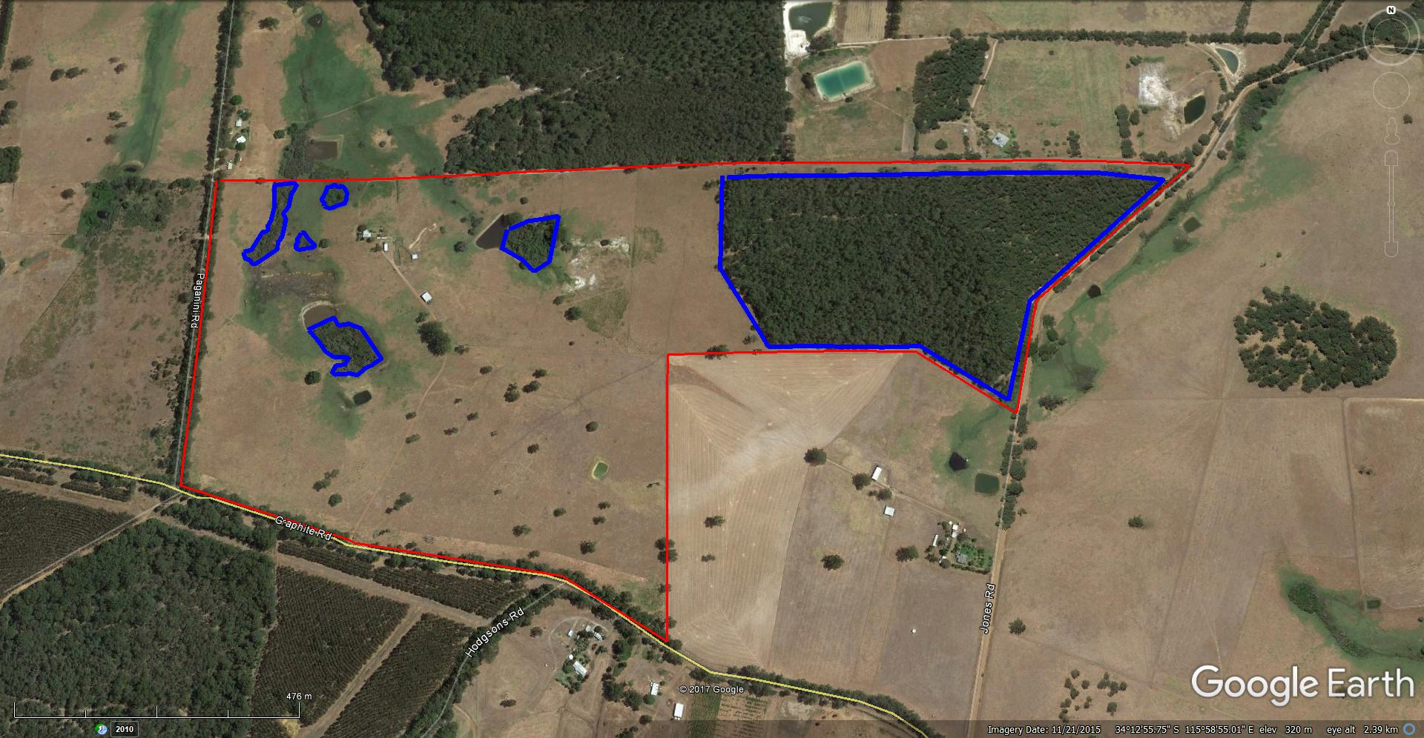

**Brett Waugh Location 9185 Graphite Rd Manjimup**

**LEGEND**

___ **Proposed Clearing area number (1) = 21 hectares**

___ **Proposed Clearing area number (2) = .75 hectares**

___ **Proposed Clearing area number (3) = .2 hectares**

___ **Proposed Clearing area number (4) = .6 hectares**

___ **Proposed Clearing area number (5) = .1 hectares**

____ **Proposed Clearing area number (6) = .8 hectares**

___ **Property Boundary**

**Total Area proposed for clearing = 23.45 hectares**

5

6

1

2

3

4