**Alexander Bay Road**

**Limestone Extraction Site**

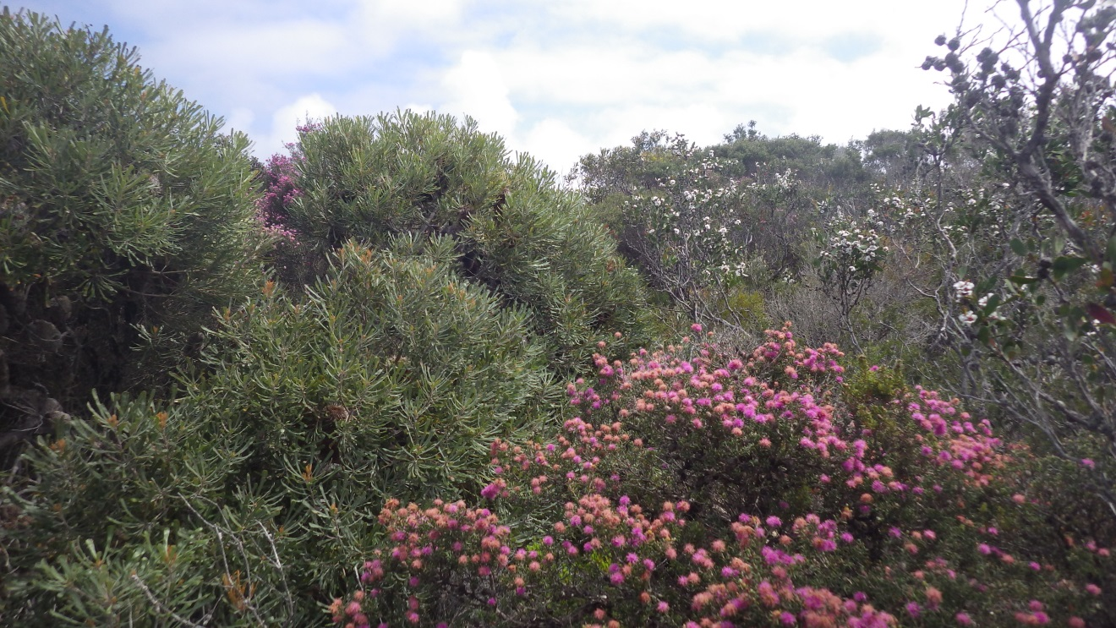

**Level 1 Flora and Vegetation Survey**

**October 2017**

**Julie Waters (BEnvSci)**

**Environmental Officer - Shire of Esperance**

## EXECUTIVE SUMMARY

The Esperance Shire wishes to create a limestone pit on Alexander Road and in doing so requires the clearing of native vegetation in order to extract road material. The 1.6 hectare Alexander Road site is located 80 km east of Esperance on the south coast of Western Australia.

A level 1 flora survey was undertaken during October 2017 in accordance with Technical Guidance – Flora and vegetation Surveys for Environmental Impact Assessment (EPA, 2016).

The site is part of a Shire managed reserve (R 39409) and has traditionally been used as a recreation and camping area. The Shire wishes to enact scheme clause (3) within the Shire of Esperance Local Town Planning Scheme 24 which states:

(3) Despite anything contained in clause 14, a reserve may be used by the local government for the purposes of developing or maintaining public infrastructure.

The campground at Alexander Bay, to the west of the proposed extraction site is currently unable to be accessed in wet weather conditions, as it requires urgent upgrade and resurfacing. The current road conditions also act as a vector to enable Phytopthora dieback to be spread. Upgrading the track into this site has been recommended by South Coast NRMs Project Dieback team.

## INTRODUCTION

The 1.6 hectare Alexander Road site is located 80 km east of Esperance on the south coast of Western Australia (Figure 1). A level 1 flora survey has been undertaken of the site in accordance with EPA Technical Guidance – Flora and vegetation Surveys for Environmental Impact Assessment (2016).

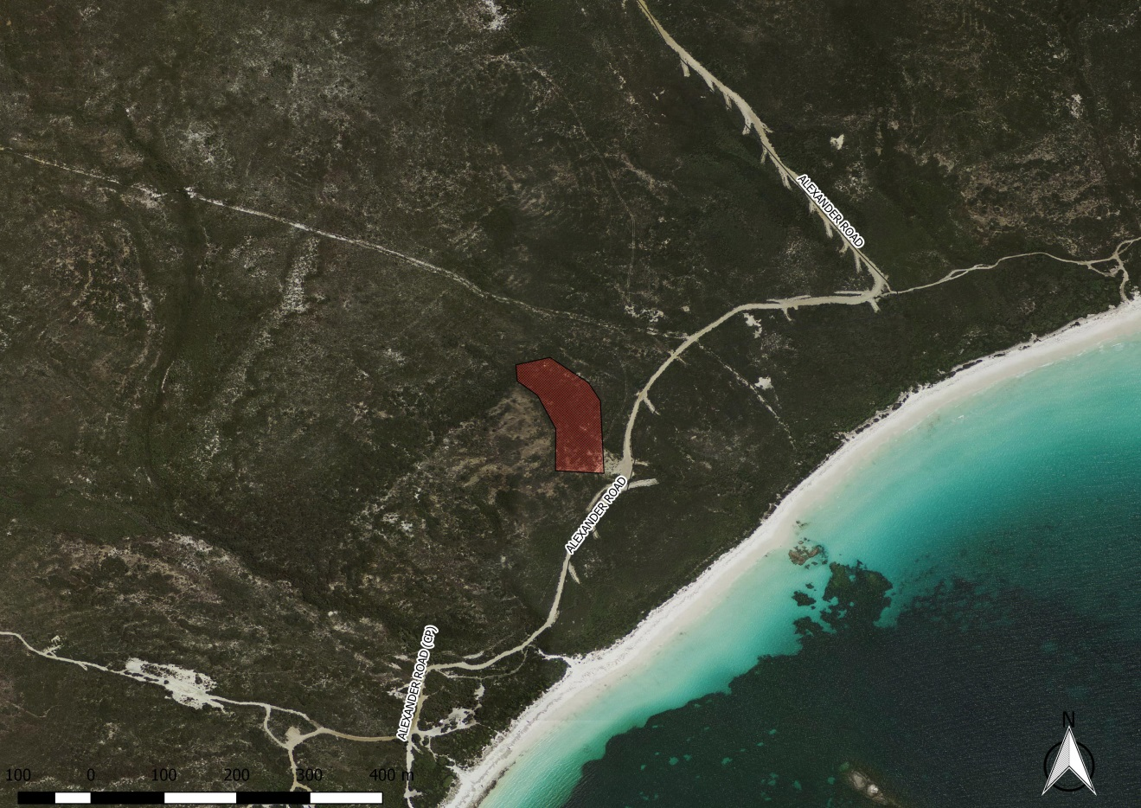

Figure 1 Location of Alexander Road survey site

## BACKGROUND

The proposed limestone extraction site has the potential to affect a number of possible environmental factors which have been outlined by DPaW. These include;

* Threatened Flora (TF) and Priority Flora (PF) within a ten kilometre radius.
* Threatened Ecological Communities

The focus of this report will be on the TF, PF, TEC and level 1 flora survey.

### Scope

As outlined in EPA schedule 51, the scope of the level 1 flora survey is in two parts being;

1. A desktop study for the purposes of gathering background information on the target area, and;
2. Reconnaissance survey to understand the likely presence of vegetation communities and flora species identified from the background study, define flora and vegetation units, their condition and potential impacts.

The survey involves low intensity sampling of flora to produce a species list, and maps of vegetation types and condition.

### Land use

The Site is within a 229 ha Crown Land Reserve – Management Order for Shire of Esperance (R 39409). The area has traditionally been used as a camping and recreation area, containing the well-used Alexander Bay Campground, which is managed by the Shire of Esperance. The reserve is surrounded by a crown land reserve 7594 ha in size.

## METHODOLOGY

### Desktop study

A desk top study of existing geospatial information was undertaken prior to the site visit as part of the level 1 survey. This included using a Geographical Information System (GIS) to review existing site digital orthophotos, geology, morphology, wetlands, native vegetation, IBRA classification, TF, PF and TEC’s.

State and Commonwealth database searches for potential DRF, PF, and Threated Ecological Communities (TEC), within a ten kilometre buffer of the survey sites was undertaken as part of the desktop study. Additional liaison with the Esperance DPaW District Flora officer was conducted to further refine conservation values of interest and to define the ten kilometre buffer due a lack of TF and PF data across the District.

### Field investigation

The preliminary field survey was during spring on 23 October 2017. The Esperance Shire provided coordinates for the site which were uploaded from GIS into a Garmin GPSmap 60CSX unit and a field aerial photo map was used to navigate to different habitat areas. A portable field herbarium was established and a preliminary species list developed.

A combination of local botanical knowledge, botanical field guides, the DPaW Esperance District Herbarium and Florabase were used to prepare a plant species lists for each site (Appendix 1).

The condition of vegetation is a subjective assessment of how healthy the vegetation is at the time of the survey. This was based on the amount of dead or dying plants throughout the stratum compared to the amount of living plants and weed cover. This was categorized as “Excellent,” “Very Good,” “Good,” “Degraded,” or “Completely Degraded.” The categories are derived from Keighery 1994, and outlined in further detail in Appendix 2.

### Analysis methodology

Findings from the desktop study and field survey were reviewed against whether the site would affect any of the following environmental values:

* The presence or absence of TF, PF and TEC’s and
* The area and condition of remnant vegetation.

## RESULTS

### Desktop study

### Vegetation

The site comprises the Fanny Cove (42) vegetation system. Comprises of Eucalyptus mixed open mallee shrubland / Melaleuca open shrubland and contains the following species; *Eucalyptus angulosa, Acacia cyclops, Agonis flexuosa, Scaevola crassifolfa, Melaleuca pentagona, Melaleuca sclerophylla.*

**Flora:**

The Declared and Endangered flora list (DEFL) database search and liaison with the Esperance DPaW District Flora Officer resulted in 3 known PF species and two known DRF Vulnerable species sites within a ten kilometre radius of the survey area (Table 1). Appendix 3 provides a description of each priority conservation status.

Table 1 Priority Flora sites within a 10 km radius of the survey area

|  |  |  |  |  |  |  |
| --- | --- | --- | --- | --- | --- | --- |
|  | **Number PF Sites** | |  |  |  |  |
| **Taxon** | DRF - Vuln | P 1 | P 2 | P 3 | P 4 | **Total** |
| *Hibbertia hamata* |  |  |  | 1 |  | 1 |
| *Lambertia echinata subsp. echinata* | 1 |  |  |  |  | 1 |
| *Lepidium pseudotasmanicum* |  |  |  |  | 1 | 1 |
| *Myoporum velutinum* | 5 |  |  |  |  | 5 |
| Verticordia verticordina |  |  |  | 1 |  | 1 |
| **Total** | **6** |  |  | **2** | **1** | **9** |

*Lambertia echinata* subsp. *echinata*: Prickly, much-branched, non-lignotuberous shrub, to 1.5 m high. Flowers orange-red-pink from September to October. Gravelly sandy loam, brown sandy loam, white-grey sand, granite, laterite. Below & between rock outcrops, slopes, hill crests. This species is unlikely to be present at the site due to absence of gravelly soils.

*Myoporum velutinum*:Shrub, 1-2 m high. Fl. white, Sep. Sandy soils. Creek banks. May be present.

*Hibbertia hamata:* Erect shrub, up to 0.5m high. Flowers yellow, October to December. Granite and Inland outcrops. May be present.

*Lepidium pseudotasmanicum:* Erect annual or biennial herb. 0.2-0.4m high. Flowers white to green during February or December. Loam,sand.May be present.

*Verticordia verticordina:* Spreading to prostrate shrub. 0.1-0.3m high. Flowers green/white and red/brown. August to October or December. Sand/Clay.May be present.

As the botanist was unfamilar with *Lepidium pseudotasmanicum*, further details were sought prior to survey.



### Erect annual or biennial herb to 40 cm high, stem glabrous or with scattered airs. Leaves with short hairs, basal leaves to 9 cm long, pinnate with narrow linear lobes, stem leaves reducing to linear and entire. Inflorescence an elongating spike with small white flowers, petals reduced or absent. Flowers possibly throughout the year.

### A perennial, weedy looking erect herb between 60-70 cm high. Stems: The stem is hairless, smooth and round in cross section. Leaves: The lower stem leaves are shortly toothed and the upper leaves are entire or with the tip shortly toothed. Flowers: The flowers are green, tinged with purple, minute and borne on an elongating stem. Flowering occurs from spring to autumn. Fruit: The fruit is an ovate pod. Each plant produces a large amount of seed (description Curtis & Morris 1975). Most herbarium specimens have been collected from August to April. Occurs on bare ground in grassland and grassy woodland.

### PERTH 03217590 [*Lepidium* *pseudotasmanicum*](https://florabase.dpaw.wa.gov.au/search/advanced?id=3042) Brassicaceae

Description: Compact low branching plant, a little under 1 m high, a little over 1 m wide.  
**Site Description:** Edge of alkaline creek, growing in alkaline soil.  
**Locality:** Munglinup Creek (c. 4 km from coast), 70 km W of Esperance  
**Location:** [-33.578°, 120.816°](http://maps.google.com/?q=-33.57805556,120.81638889) (GDA94)  
**Collector:** Archer, W.R. **Collection Date:** 4 January 1990

**TEC/PEC:**

The database search resulted in one known occurrences of TEC that being the Proteaceae dominated kwongkan shrublands of the southeast coastal floristic province of Western Australia falling within approximately half of the proposed clearing area.

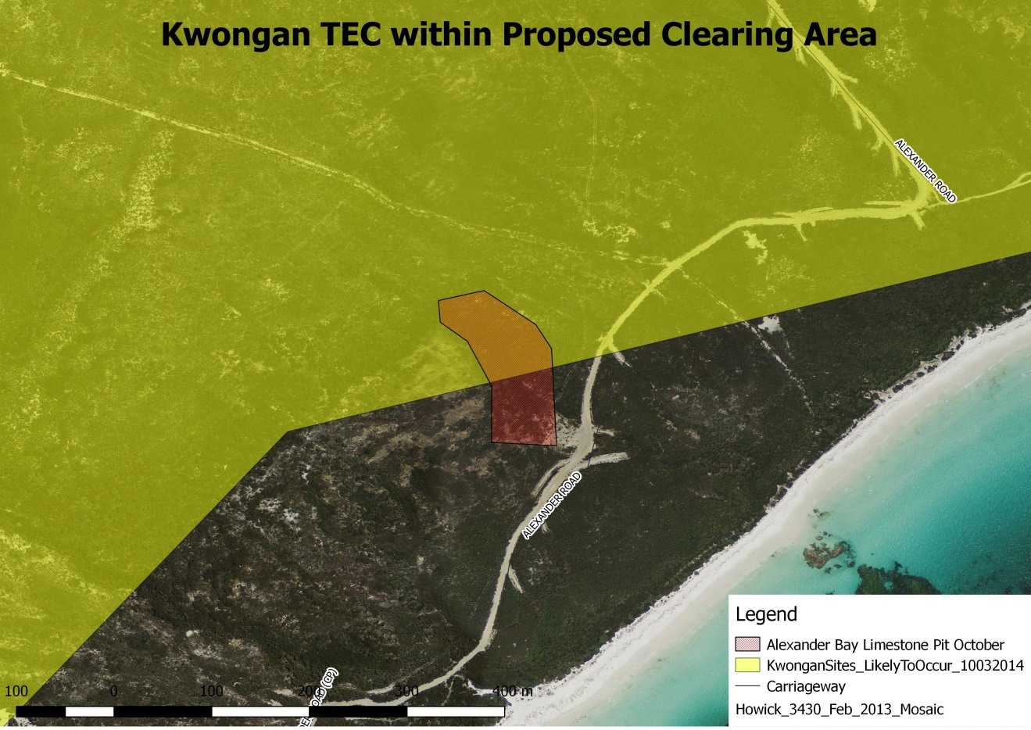

Figure 2. Occurrence of Proteaceae dominated kwongkan shrublands of the southeast coastal floristic province of Western Australia highlighted in yellow. The site is circled red.

### Field survey

The field survey was undertaken on the 23/10/2017. A wandering traverse of the site was undertaken collecting herbarium specimens for later identification.

**Vegetation**

The vegetation consisted mostly of Eucalyptus angulosa open mallee shrubland over *Melaleuca pentagona / Taxandria spathulata* shrubland, pockets of *Banksia* mixed heath also occurred in the area. The area was extremely diverse with a total of 52 species collected within the 1.6ha area. (see Appendix 1).

**Site photos**

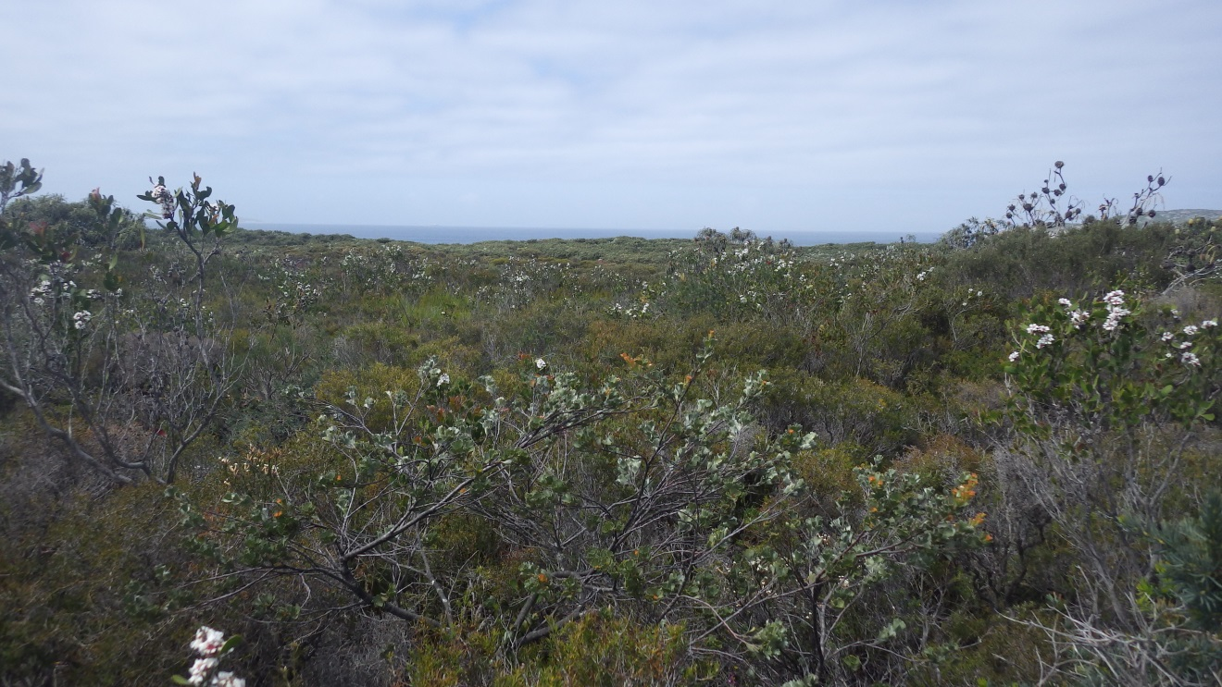



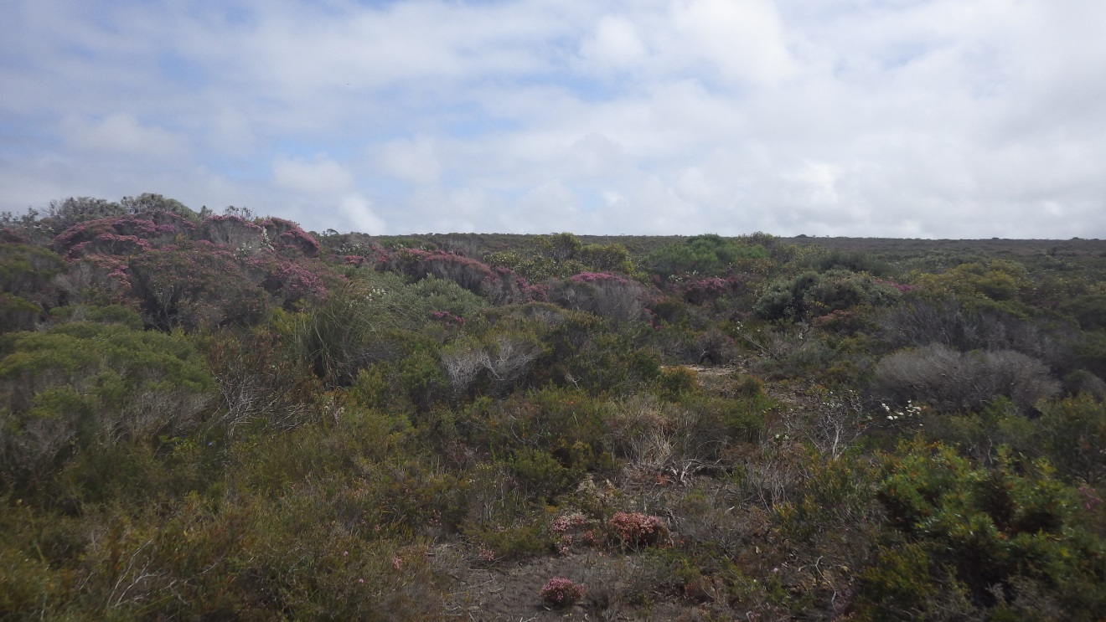

Threatened and Priority Flora

The P3 species *Verticordia verticordina* priority flora were present at the site. 6 plants were found at the southern part of the application area.

The P4 species *Thysanotus parviflorus* may have been found (awaiting positive identification). 20 plants were found within the application area.

### Vegetation condition rating

The vegetation was in excellent condition however the site is very close to a known dieback infested area and had at least one suspect plant in the area. Shallow soils and creekline in the area also make it vulnerable to dieback spread and it is likely that this area is currently on its way to being dieback infested. This condition rating is likely to be downgraded in the future.

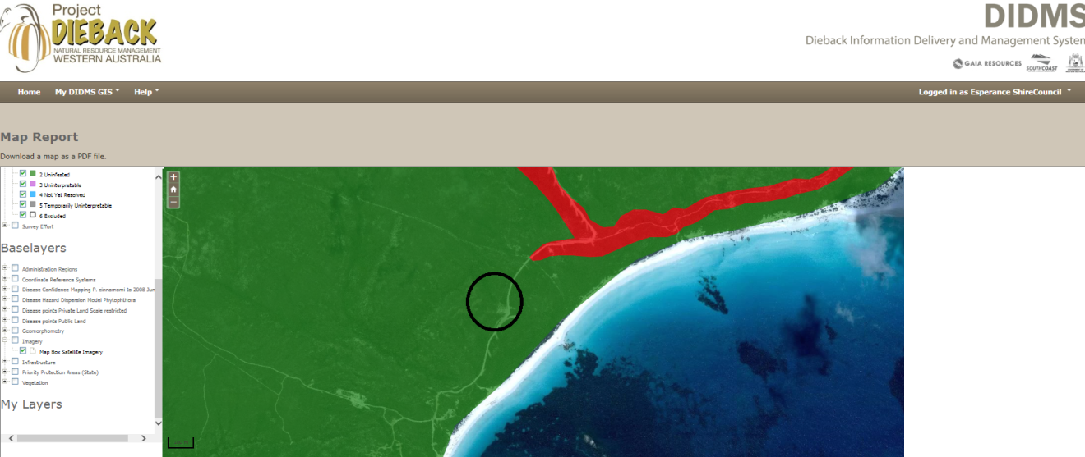

According to Project Dieback’s – Dieback Information Delivery and Management System (DIDMS) the site is listed as uninfested, however is 300m south of an infested area.

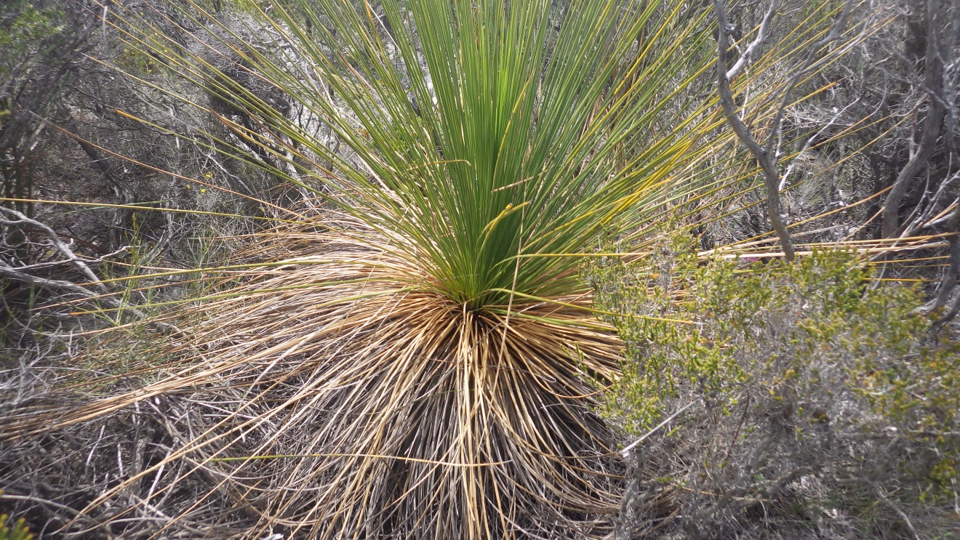

Suspected Phytopthora dieback infested dying Xanthorea were noted during the survey

**Threatened Ecological Community**

The database search resulted in one known occurrences of TEC that being the Proteaceae dominated kwongkan shrublands of the southeast coastal floristic province of Western Australia. During the field study it was confirmed that the area was part of the TEC due to the presence a large number of diagnostic species as well as >30% cover of proteaceous species. It should be noted that the long term ability to this site to meet the TEC definition is severely compromised due to the presence of dieback at the site.

Proteaceae dominated kwongkan shrublands of the southeast coastal floristic province of Western Australia diagnostic species:

|  |  |  |
| --- | --- | --- |
|  | | |
| **Diagnostic species Esperance (east)** | **Present at Alexander Bay road site** |  |
| *Adenanthos cuneatus* | *Banksia armata* |  |
| *Banksia alliacea* | *Banksia media* |  |
| *Banksia armata* | *Banksia nutans* |  |
| *Banksia cirsioides* | *Banksia pulchella* |  |
| *Banksia media* | *Banksia speciosa* |  |
| *Banksia nivea* | *Hakea corymbosa* |  |
| *Banksia nutans* | *Hakea pandanicarpa* |  |
| *Banksia obovata* | *Hakea trifurcata* |  |
| *Banksia occidentalis* | *Isopogon polycephalus* |  |
| *Banksia petiolaris* |  |  |
| *Banksia pilostylis* |  |  |
| *Banksia plumosa* |  |  |
| *Banksia prolata* |  |  |
| *Banksia pulchella* |  |  |
| *Banksia speciosa* |  |  |
| *Banksia repens*  *Banksia tenuis* |  |  |
| *Grevillea concinna* |  |  |
| *Hakea cinerea* |  |  |
| *Hakea corymbosa* |  |  |
| *Hakea drupacea* |  |  |
| *Hakea nitida* |  |  |
| *Hakea obliqua* |  |  |
| *Hakea pandanicarpa* |  |  |
| *Hakea trifurcata* |  |  |
| *Isopogon formosus* |  |  |
| *Isopogon heterophyllus* |  |  |
| *Isopogon polycephalus* |  |  |
| *Isopogon trilobus* |  |  |
| *Lambertia inermis* |  |  |

### Threats

The site consists of a vegetation community susceptible to dieback. The nearest positive dieback sample is recorded 300m from the site. The site is currently listed as uninfested on the Dieback Information Delivery and Management System (DIDMS) however this information is now out of date (2009 survey data).

## CONCLUSION

The site contains a high level of biological diversity, as well as at least one (and possibly two) species of Priority flora. Clearing of this site will result in the removal of 1.6ha of the Proteaceae dominated kwongkan shrublands of the southeast coastal floristic province of Western Australia Threatened Ecological Community. The Shire of Esperance acknowledges this and will be willing to provide Environmental Offsets for this clearing. The Shire of Esperance is limited by available close limestone to the campsite due to Aboriginal Heritage site and tenure constraints as well as economic constraints by having to source limestone outside Reserve 39409. Due to the possible dieback in the area, this limestone will only be used on the existing track where dieback is present and not further north of the current mapped PC boundary.

***REFERENCES***

Department of Environment and Conservation (2007a) Florabase. The Flora of Western Australia Online (and collections housed at the WA Herbarium). [www.florabase.calm.wa.gov.au](http://www.florabase.calm.wa.gov.au)

Freebury, G (2009) *Dieback Interpretation Report - Cape Arid, Kennedy, Alexander and Daniels Rd Reserves*, Department of Environment and Conservation

Environmental Protection Authority (2016) Technical **Guidance** – Flora and **Vegetation** Surveys for Environmental Impact Assessment

*Environment Protection and Biodiversity Conservation Act 1999* (EPBC Act) (s266B) *Approved Conservation Advice for Proteaceae Dominated Kwongkan Shrublands of the southeast coastal floristic province of Western Australia*

Gaia Resources (2017) *DIDMS Dieback Information Delivery and Management System* https://didms.gaiaresources.com.au/

Keighery, B. (1994) *Bushland plant survey : a guide to plant community survey for the community*, Wildflower Society of WA

Beckwith J (2010) *Local Area Stakeholder Engagement and Phythophthora dieback Action Plan Esperance (East)* South Coast Natural Resource Management Inc.

## APPENDICES

Appendix 1: Species list for surveyed study area

Appendix 2: Bushland Condition Ratings

Appendix 3 Conservation status descriptions

### Appendix 1: Species list for surveyed study area

**Legend**

* Status refers to conservation status
* * refers an introduced weed species
* 1 refers to species presence, and blank is absent.

|  |  |  |  |  |
| --- | --- | --- | --- | --- |
| **Family** | **Genus** | **Species** | **Subspecies** | **Status** |
| Asparagaceae | Thysanotus | parviflorus? |  | P4 |
| Boraginaceae | Halgania | anagaloides | Var. Southern | |
| Cyperaceaea | Gahnia | trifida |  |  |
| Dilleniaceae | Hibbertia | acerosa |  |  |
| Dilleniaceae | Hibbertia | andrewsii |  |  |
| Dilleniaceae | Hibbertia | gracilipes |  |  |
| Dilleniaceae | Hibbertia | recurvifolia |  |  |
| Droseraceae | Drosera | Sp. |  |  |
| Ericaceae | Andersonia | parviflora |  |  |
| Ericaceae | Leucopogon | fimbriatus |  |  |
| Ericaceae | Lysenema | ciliatum |  |  |
| Ericaceae | Oligarrhena | micrantha |  |  |
| Fabaceae | Acacia | nigricans |  |  |
| Fabaceae | Acacia | subcaerulea |  |  |
| Fabaceae | Acacia | triptycha |  |  |
| Fabaceae | Daviesia | incrassata | |  |
| Fabaceae | Dillwynia | divaricata |  |  |
| Fabaceae | Jacksonia | viscosa |  |  |
| Goodeniaceae | Dampiera | fasciculata |  |  |
| Lauraceae | Cassytha | Sp. |  |  |
| Malvaceae | Lasiopetalum | quinquenervium |  |  |
| Myrtaceae | Beaufortia | micrantha |  |  |
| Myrtaceae | Beaufortia | schaueri |  |  |
| Myrtaceae | Calothamnus | quadrificus |  |  |
| Myrtaceae | Calytrix | decandra |  |  |
| Myrtaceae | Melaleuca | pentagona |  |  |
| Myrtaceae | Melaleuca | striata |  |  |
| Myrtaceae | Melaleuca | suberosa |  |  |
| Myrtaceae | Taxandria | spathulata |  |  |
| Myrtaceae | Agonis | baxteri |  |  |
| Myrtaceae | Darwinia | diosmoides |  |  |
| Myrtaceae | Eucalyptus | angulosa |  |  |
| Myrtaceae | Verticordia | verticordina |  | P3 |
| Polygalaceae | Comesperma | virgatum |  |  |
| Proteaceae | Adenanthos | cuneatus |  |  |
| Proteaceae | Banksia | armata |  |  |
| Proteaceae | Banksia | media |  |  |
| Proteaceae | Banksia | nutans |  |  |
| Proteaceae | Banksia | pulchella |  |  |
| Proteaceae | Banksia | speciosa |  |  |
| Proteaceae | Conospermum | teretifolium | |  |
| Proteaceae | Hakea | corymbosa |  |  |
| Proteaceae | Hakea | pandanicarpa |  |  |
| Proteaceae | Hakea | trifulcata |  |  |
| Proteaceae | Isopogon | polycephalus |  |  |
| Proteaceae | Petrophile | fastigiata |  |  |
| Restionaceae | Hypolaena | exsulca |  |  |
| Rutaceae | Boronia | atlata |  |  |
| Stylidiaceae | Stylidium | macranthum |  |  |
| Stylidiaceae | Stylidium | piliferum |  |  |
| Thymelaeaceae | Pimelea | angustifolia |  |  |
| Xanthorrhoeaceae | Xanthorrhoea | platyphlla |  |  |

|  |  |  |  |
| --- | --- | --- | --- |
|  |  |  |  |

### Appendix 2: Bushland Condition Ratings[1]

|  |  |
| --- | --- |
| **Condition** | **Description** |
| Excellent | Vegetation structure intact, with disturbance affecting individual species and weeds consist of non-aggressive species. 1 – 5% weed cover |
| Very Good | Vegetation structure altered, with obvious signs of disturbance. For example, disturbance to vegetation structure caused by repeated fires, the presence of some more aggressive weeds, dieback, logging and/or grazing. 5 – 25% weed cover |
| Good | Vegetation structure significantly altered by very obvious signs of multiple disturbances. Retains basic vegetation structure or ability to regenerate it. For example, disturbance to vegetation structure caused by very frequent fires, the presence of some very aggressive weeds at high density, partial clearing, dieback and/or grazing. 25 – 50% weed cover |
| Degraded | Basic vegetation structure severely impacted by disturbance. Scope for regeneration but not to a state approaching good condition without intensive management. For example, disturbance of vegetation structure caused by very frequent fires, the presence of very aggressive weeds, partial clearing, dieback and/or grazing. 50 – 75% weed cover |
| Completely  Degraded | The structure of the vegetation is no longer intact and the area is completely, or almost completely, without native species. These areas are often described as “parkland cleared” with the flora comprising weed or crop species with isolated native trees or shrubs. 75 – 100% weed cover |

### Appendix 3 Conservation Status Descriptions

Definitions of conservation codes given to Declared Rare and priority flora.

KJ Atkins, 15 July 1998, Department of Conservation and Land Management

**R: Declared Rare Flora – Extant Taxa**

Taxa which have been adequately searched for and are deemed to be in the wild either rare, in danger of extinction, or otherwise in need of special protection, and have been gazetted as such.

**P1: Priority One – Poorly Known Taxa**

Taxa that are known from one or a few (generally less than five) populations, which are under threat, either due to small population size, or being on lands under immediate threat, e.g. road verges, urban areas, farmland, active mineral leases, or the plants are under threat, e.g. from disease, grazing by feral animals. May include taxa with threatened populations on protected lands. Such taxa are under consideration for declaration as ‘rare flora’, but are in urgent need of further survey.

**P2: Priority Two – Poorly Known Taxa**

Taxa which are known from one or a few (generally less than five) populations, at least some of which are not believed to be under immediate threat (i.e. not currently endangered). Such taxa are under consideration for declaration as ‘rare flora’, but are in urgent need of further survey.

**P3 Priority Three – Poorly Known Taxa**

Taxa that are known from several populations, and the taxa are believed to be not under immediate threat (i.e. not currently endangered), either due to the number of known populations (generally more than five), or known populations being large, and either widespread or protected. Such taxa are under consideration for declaration as ‘rare flora’, but are in need of further survey.

**P4 Priority Four – Rare Taxa**

Taxa which are considered to have been adequately surveyed and which, while being rare (in Australia), are not currently threatened by any identifiable factors. These taxa require monitoring every 5-10 years.

Note: The need for further survey of poorly known taxa is prioritised into the three categories depending on the perceived urgency for determining the conservation status of those taxa, as indicated by the apparent degree of threat to the taxa on the current information.

1. Adapted from Keighery, 1994 and the Braun-Blanquet Scale of Cover Abundance [from Mueller-Dombois and Ellenberg, 1974]