Clearing Permit 2018-2019 Mountford Road August 2018
Supporting documentation and site survey photographs.
Original application was for a blanket permit for entire road reserve without detailed design provided. Information was subsequently gathered to provide supporting information about vegetation retention in lieu of a detailed design.
Desktop assessment was completed in August 2018 using the Environmental Planning Tool provided by WALGA and supported by Shire of Dardanup Intramaps, undertaken by Senior Environment Officer, Jackie Nichol, at Shire of Dardanup.
Results found:
- No records of Significant or Priority Flora, Fauna.
- No evidence of any Potential or Threatened Ecological Communities.
- Low Western Ringtail possum habitat suitability,
- Potential breeding area Jarrah Forest for Carnaby’s cockatoo.
- Low Roadside Conservation status.
- Vegetation has medium connectivity and over 40% vegetation community remaining in IBRA Subregion.
Site Survey: was undertaken on Friday 24th August 2018.
The trees assessed on site are predominantly Corymbia calophylla. Most contain disease (Marri canker) and several have fallen down in recent weeks with high winds. The location of the proposed road widening and on-site topography make retention of any existing trees unlikely as the widening will require considerable infill. (see photo 1).
The final design for this proposal has not been provided due to time constraints.
Photographs of typical vegetation found along road reserve are included below:
Photo 1. Facing east. Start of Clearing area near junction with Crooked brook road. Note the steep bank on the left hand side and location of tree roots, and fallen tree.
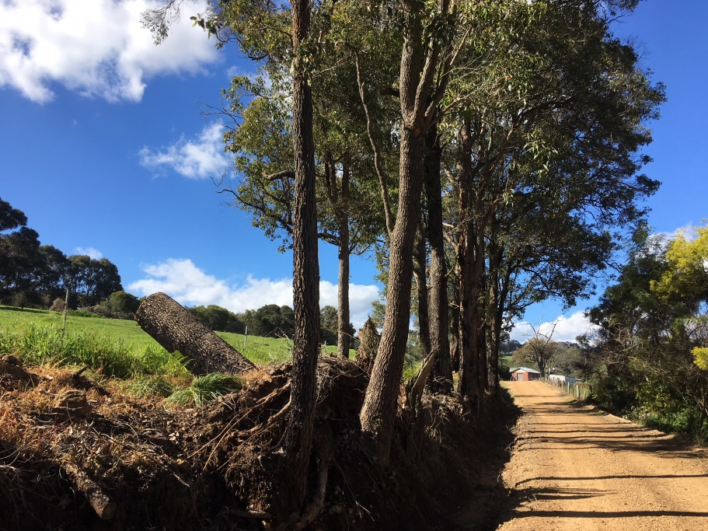

Photo 2 Mountford road facing east. Large Corymbia with disease.
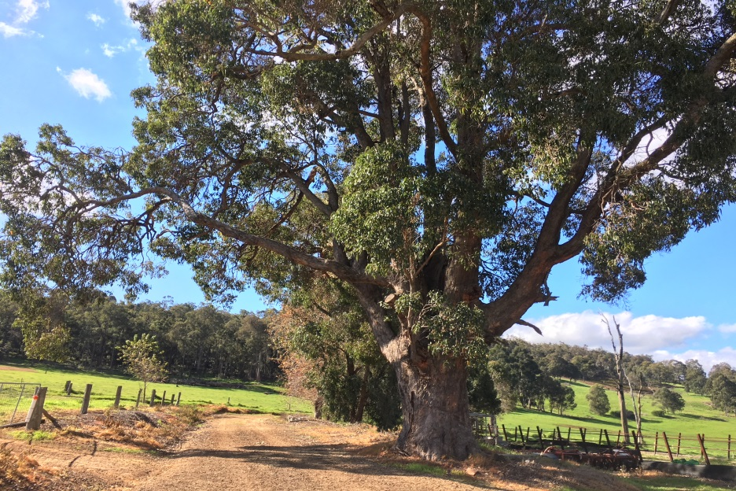
Photo 3. Facing east at end of Mountford road
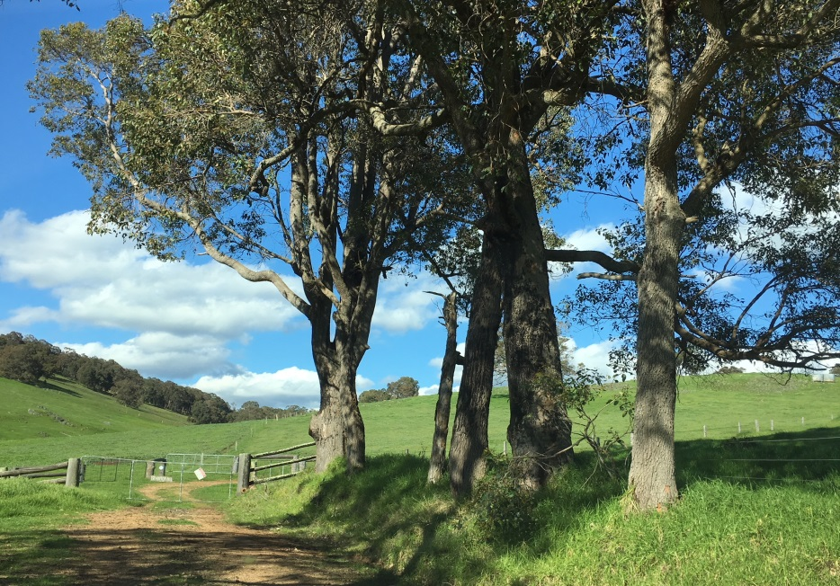
Photo 4. Facing west looking back form end of Mountford Road. Note steepness of bank.
