Clearing Permit - CPS 9143/1 - 14/1/2021 Supporting Documentation
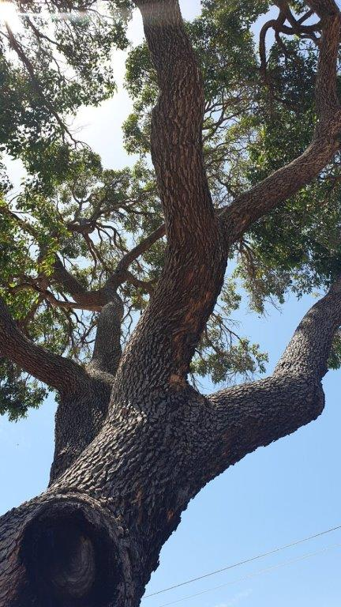
Tree 1:
Corymbia calophylla
DBH: 0.75m Ht: 14m
No hollows detected.
Mature age.
Heavily pruned for road clearance.
Marri canker present in canopy and most pruning cuts.
Significant impact damage to the trunk.
From x402572 y6452117
Tree would require removal to undertake works.

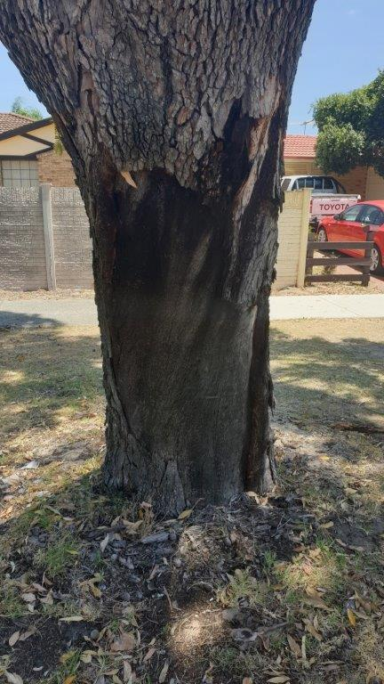
Tree 1: Significant impact damage to the base of the tree.

From x402572 y6452120
Impact damage from vehicle impact.

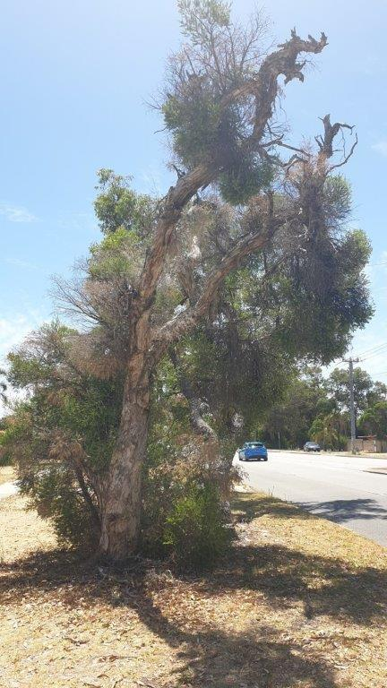
Tree 2: Melaleuca preissiana
From x402564 y6452128
DBH: O.42m, 0.35m Ht: 6.5m
Double leader
No hollows detected.
Sucker growth from the base.
No hollows detected.
Tree would require removal to undertake works.

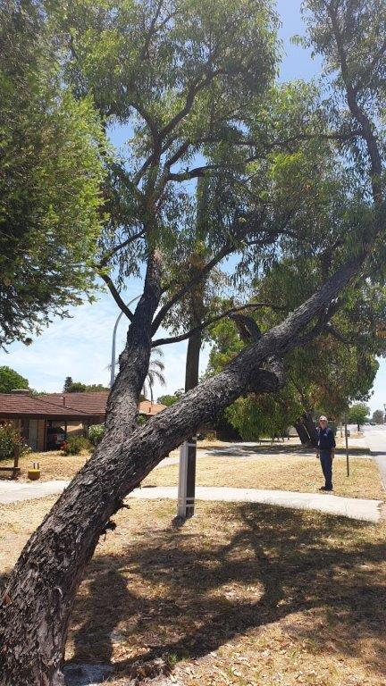
Tree 3: Eucalyptus marginata
35 degree lean from upright
DBH: 0.44m Ht: 7m
From: x402562 y6452136
No hollows detected.
Tree would require removal to undertake works.

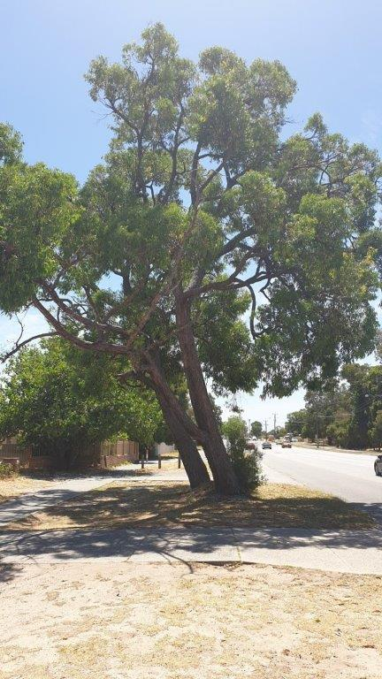
Tree 4: Double Leader Eucalyptus marginata
DBH: 0.64, 0.57m Ht:13m, 12m
Regrowth from old stump.

From: x402546 y6452150
No hollows detected.

Tree would require removal to undertake works.

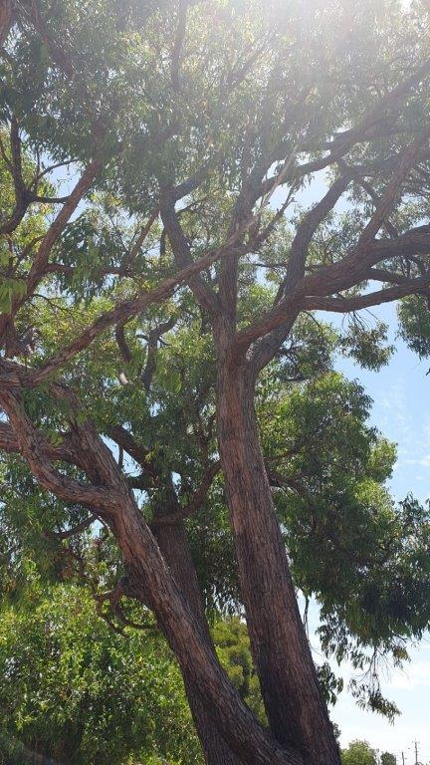
Tree 4: Canopy

From: x402541 y6452156

No Hollows detected.

